|  |  |
| --- | --- |
|  | **FPT ACADEMY INTERNATIONAL**  **FPT – APTECH COMPUTER EDUCATION** |

**Centre Name: ACE-HCMC-2-FPT.**

**Address: 590 Cach Mang Thang 8, District 3, Ho Chi Minh City, Viet Nam.**

**NEXUS SERVICE MARKETING SYSTEM**

|  |  |  |
| --- | --- | --- |
| **Supervisor:** | **Faculty Dinh Vu Quoc Trung** | |
| **Semester:** | Semester 3 | |
| **Batch No:** | T1.1707.E0 | |
| **Group No:** | 5 | |
| **Order:** | **Full name** | **Roll No.** |
| 1. | Nguyen Huu Minh | STUDENT1021979 |
| 2. | Nguyen Thanh Phat | STUDENT1038283 |
| 3. | Pham Huynh Xuan Loc | STUDENT1035257 |

Month ….. Year …

**REVIEW 1**

**Problem statement:**

1. **Introduction:**

Nexus Communication System, has expanded their service all over the territory and has even started the retail outlets at each place, so as to increase the comfort level of the customers where the customers can make the payment, also they can place an order or enquire for a new connection. They also recently started a bulk and corporate schemes, so as to retain the customers where they can avail a discount as per the option.

They want an online application to be build up which will update and maintains the records automatically. Also they want the separate login for the Admin to enter the details of the employee, Stock, vendors, retail shops.

They want a database to hold all the details of the equipment, vendors, retail shops, employers and customers, and the connections provided and that of the applied (order) details, so that they can automate the system.

The company is thus required to have an elaborate system for tracking down all the information, so as to respond to the customer queries and act based on their requirement

1. **Customer Requirement Specification:**

**A - Outlets Employees:**

Employees of the outlets are able to:

* create orders.
* search orders by given Order ID or Customer Name / Phone contact; view orders detail.
* search connections by Customer Name or Phone contact or Connection ID; view connections detail.
* search bills by Customer Name or Phone contact or Purchased date or Bill ID; view bills detail.
* view the orders’ detail.
* view the bills’ detail.
* view the connection detail.
* Create payment
* edit, update and view the payment detail.
* Search for payment.

**B - Accounts department people:**

People from Accounts departmentare able to:

* create new bill.
* edit, update and view the bills’ detail.
* search for bills by Customer Name or Phone contact or Purchased date or Bill ID.
* Create payment
* edit, update and view the payment detail.
* Search for payment.

**C - Admin:**

Admin usersare able to:

* insert new plan.
* edit, update and view the plans’ detail.
* search for plans by Type or Price.
* insert new store.
* edit, update and view the stores’ detail.
* search for stores by areas.
* insert new employee.
* to edit, update and view the employees’ detail.
* search for employees by name or ID or role or work place
* insert new account.
* edit, update and view the accounts’ detail.
* search for accounts by role.

**D - Technical people:**

Technical peopleare able to:

* edit, update and view orders.
* search orders by given Order ID or Customer Name / Phone contact.
* create new connection.
* edit, update and view the connection detail.
* Search for connections by type or id or provided date or Connection ID.
* insert new vendors
* edit, update and view the vendors’ detail.
* search for vendors by name or areas.
* insert new equipment
* edit, update and view the device detail.
* search for equipment by name or price or type.

**E - Clients:**

Clientsare able to:

* place orders for connection, cancel orders.
* view details of the provided connections.
* view details of the orders.
* Search for orders and connections on:
  + Unique id
  + Contact number

1. **Hardware / System Requirement Specification:**
   1. **Server Requirement**

**Hardware**

|  |  |
| --- | --- |
| **Component** | **Requirement** |
| CPU | Processor Type: Pentium IV-compatible processor of faster Processor speed: Recommended: 2.0 GHz or faster |
| OS | Microsoft Windows Server 2014 with IIS |
| Memory(RAM) | Ram:  Minimum: 512 MB Recommended: 2GB or more |
| Hard Drive | Free space  Minimum:500MB  Recommended: 50GB or more  Maximum: Operating system maximum |

**Software**

|  |  |
| --- | --- |
| **Component** | **Requirement** |
| Microsoft .Net framework | Version 4.5 |
| RDBMS | Microsoft SQL server 2014 |

* 1. **Client Requirement**

**Hardware**

|  |  |
| --- | --- |
| **Component** | **Requirement** |
| CPU | Processor Type: Pentium III-compatible processor of faster Processor speed: Recommended: 1.0 GHz or faster |
| OS | All OS |
| Memory(RAM) | Ram:  Minimum: 512 MB Recommended: 1GB or more |
| Hard Drive | Free space  Minimum:50MB |

**Software**

|  |  |
| --- | --- |
| **Component** | **Requirement** |
| Web Browser | Chrome or Higher |

1. **Task sheet review 1**

|  |  |  |  |  |  |
| --- | --- | --- | --- | --- | --- |
| **Project Ref. No 5** | Project Title: **Nexus service marketing system** | **Date of Preparation of activity plan** | | | |
| **No.** | **Task** | **Actual Start Date** | **Actual Days** | **Team Member names** | **Status** |
| 1 | Introduction |  | 2 | All members | Completed |
| 2 | Customer Requirement | All members | Completed |
| 3 | Hardware/Software | All members | Completed |
| 4 | Task sheet | All members | Completed |

|  |  |  |
| --- | --- | --- |
|  | **Prepare By: Group 5** | **Approved By: Faculty** |
| Date: | **Team Leader**  **Nguyen Huu Minh** | **Mr. Dinh Vu Quoc Trung** |

**REVIEW 2**

1. **Architecture of the project:**

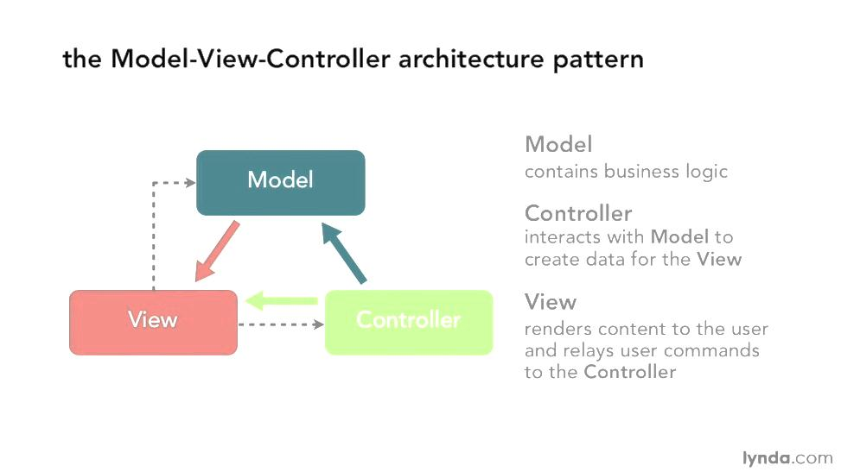

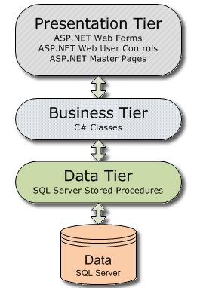

**Presentation tier:**

The presentation tier is the front end layer in the 3-tier system and consists of the user interface. This user interface is often a graphical one accessible through a web browser or web-based application and which displays content and information useful to an end user.

**Business tier:**

The Business tier contains the functional business logic which drives an application’s core capabilities. It’s often written in Java, .NET, C#, Python, C++, etc.

**Data tier:**

The data tier comprises of the database/data storage system and data access layer. Examples of such systems are MySQL, Oracle, PostgreSQL, Microsoft SQL Server, MongoDB, etc. Data is accessed by the application layer via API calls.

1. **Algorithms – Data flowchart:**

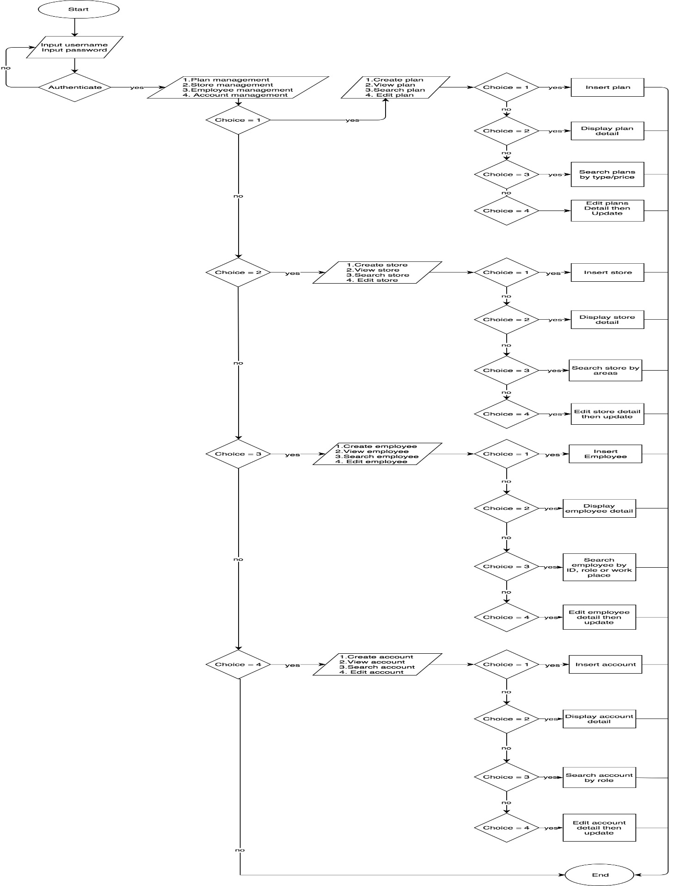**Main data flow for admin**

**Main data flow for Technical people**

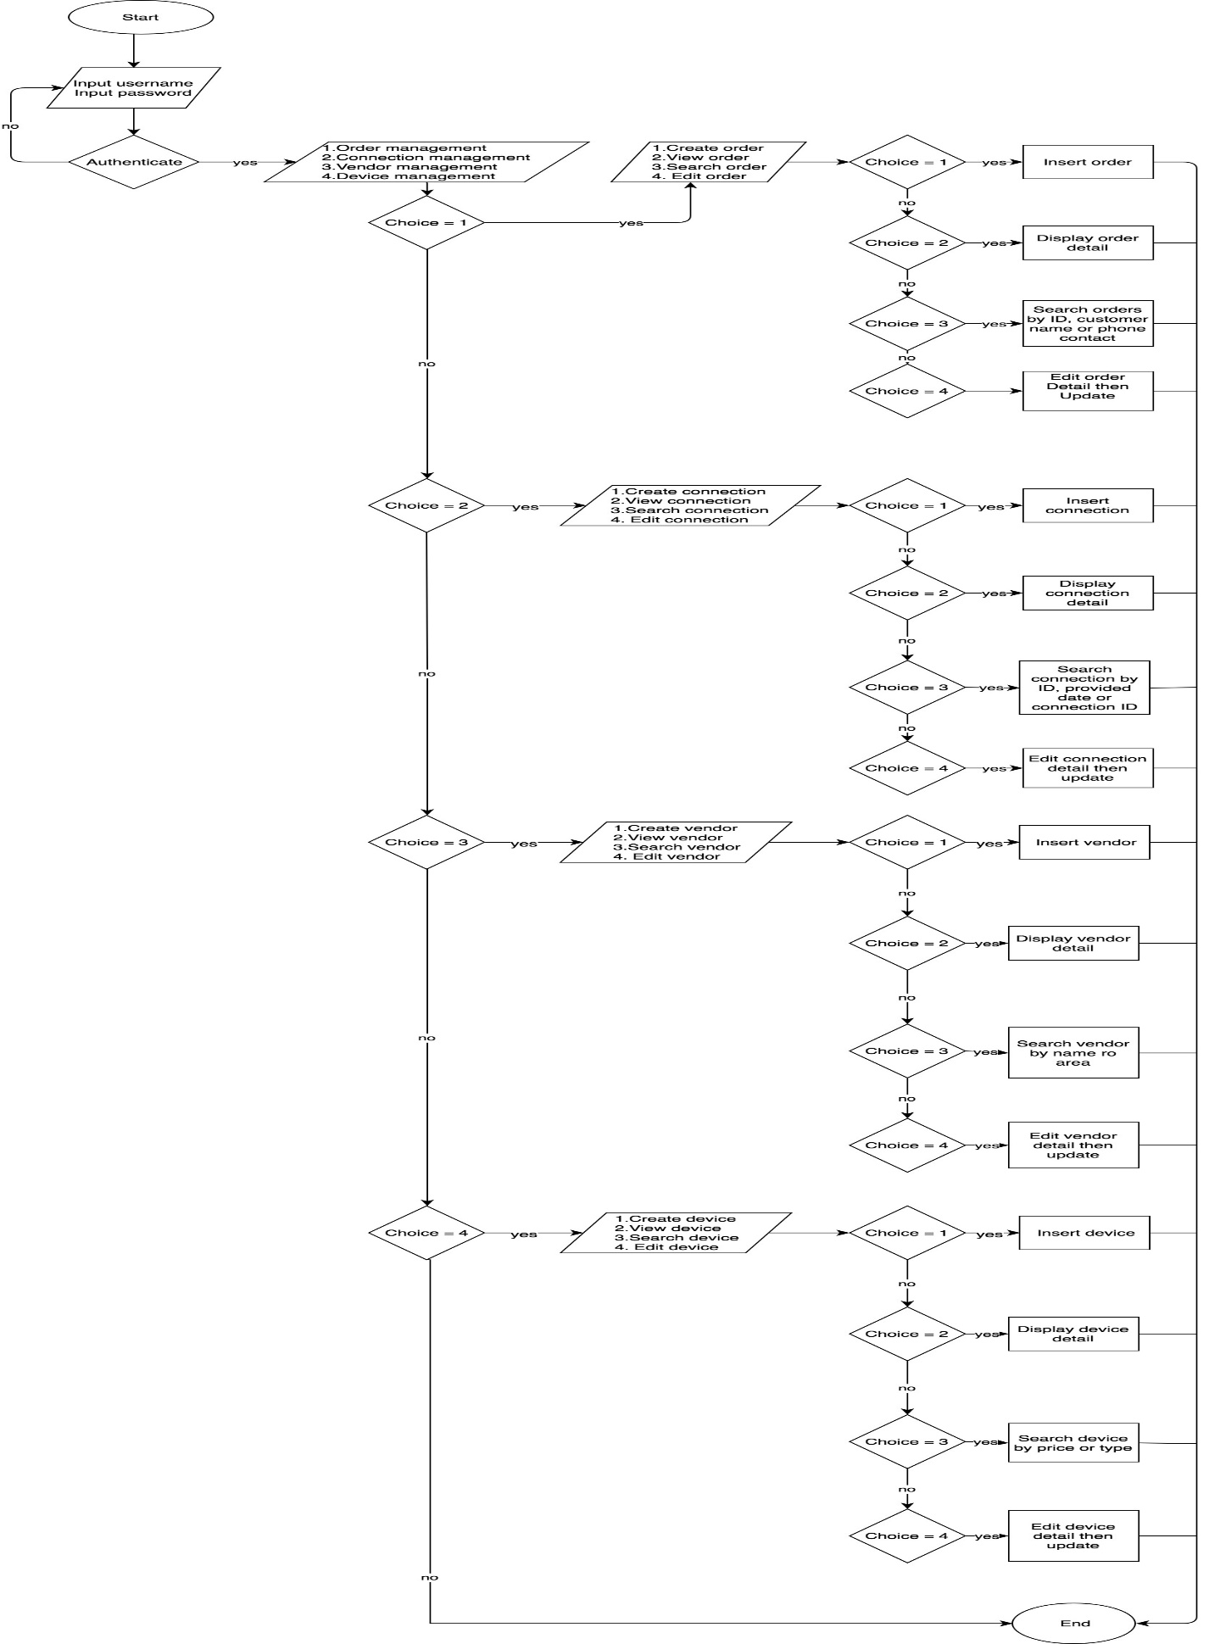

**Main data flow for Account department people**

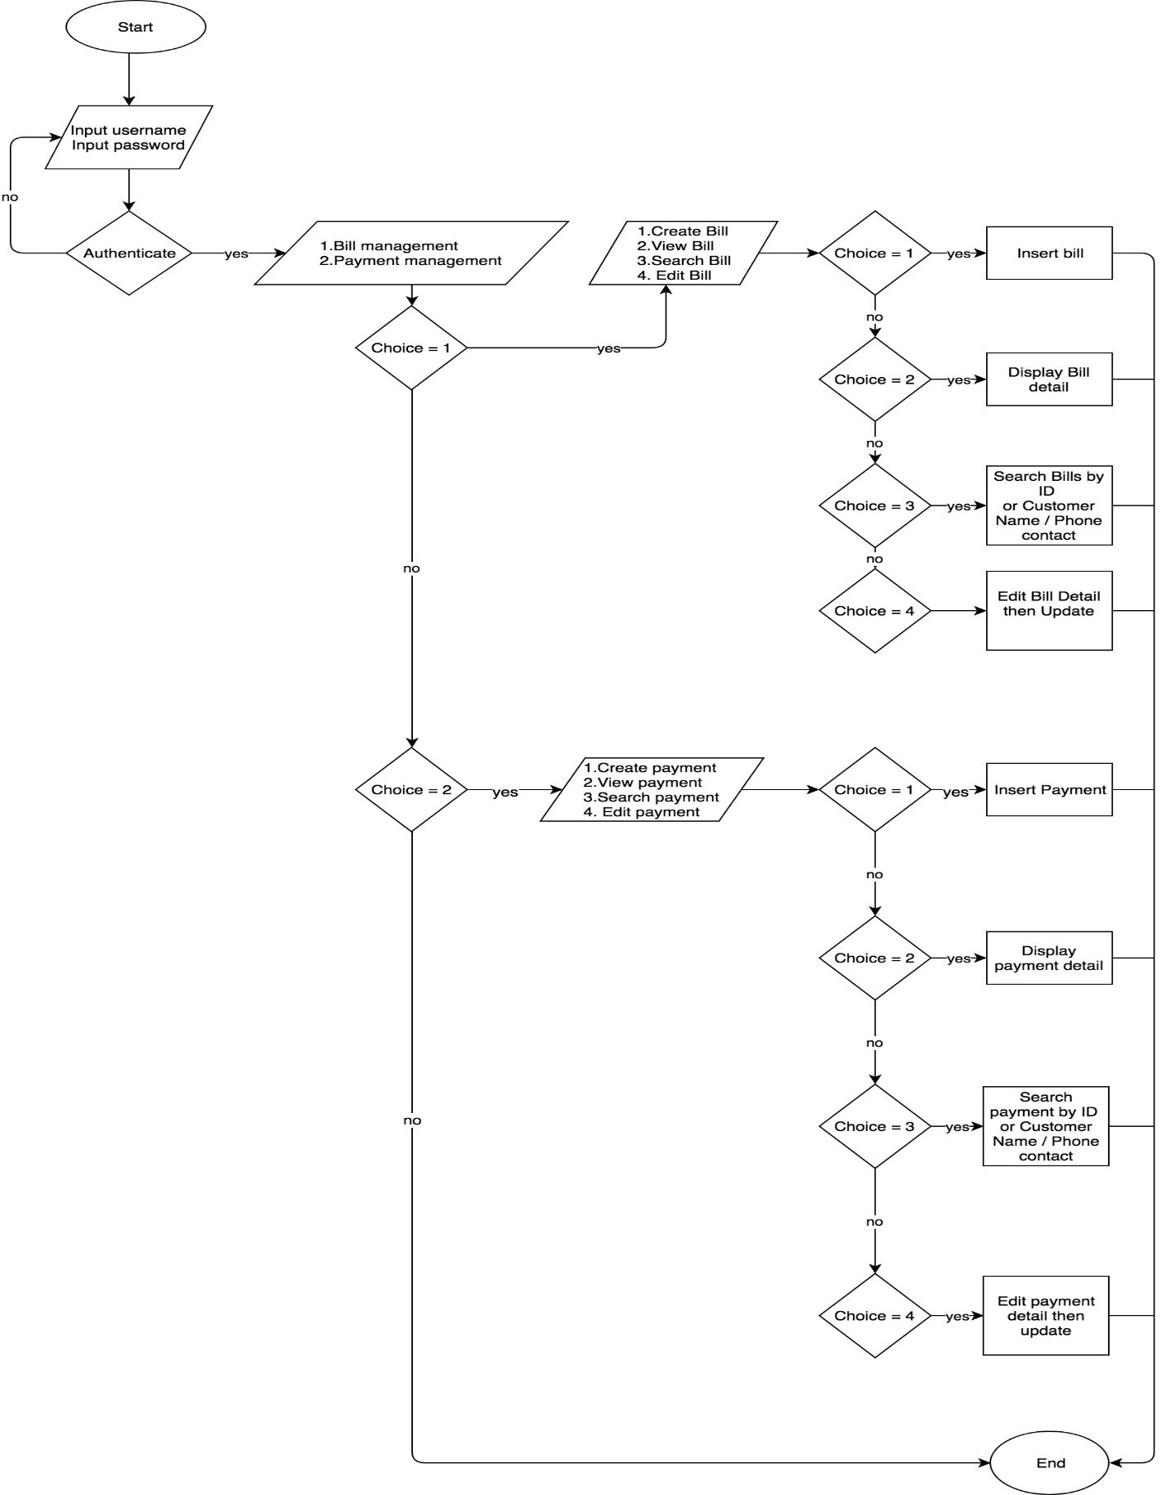

**Login process**

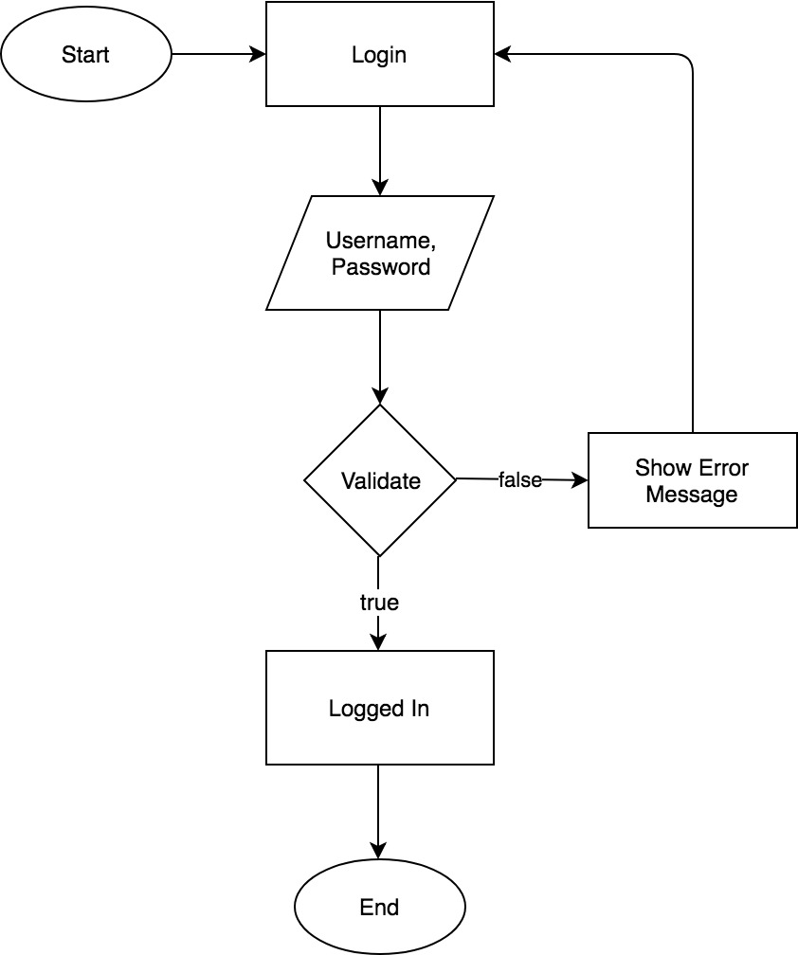

**Logout process**

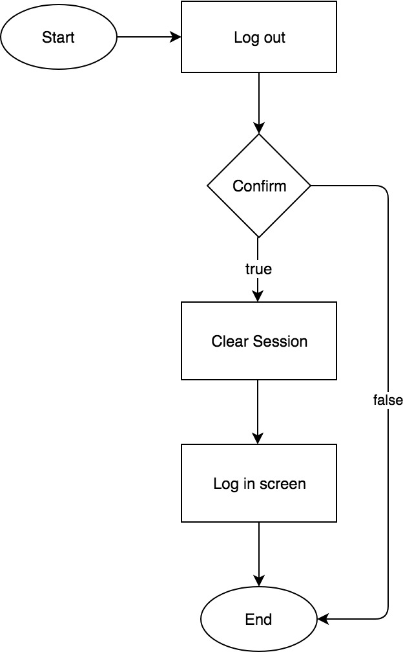

**A - Outlets Employees:**

1. **Orders**
2. 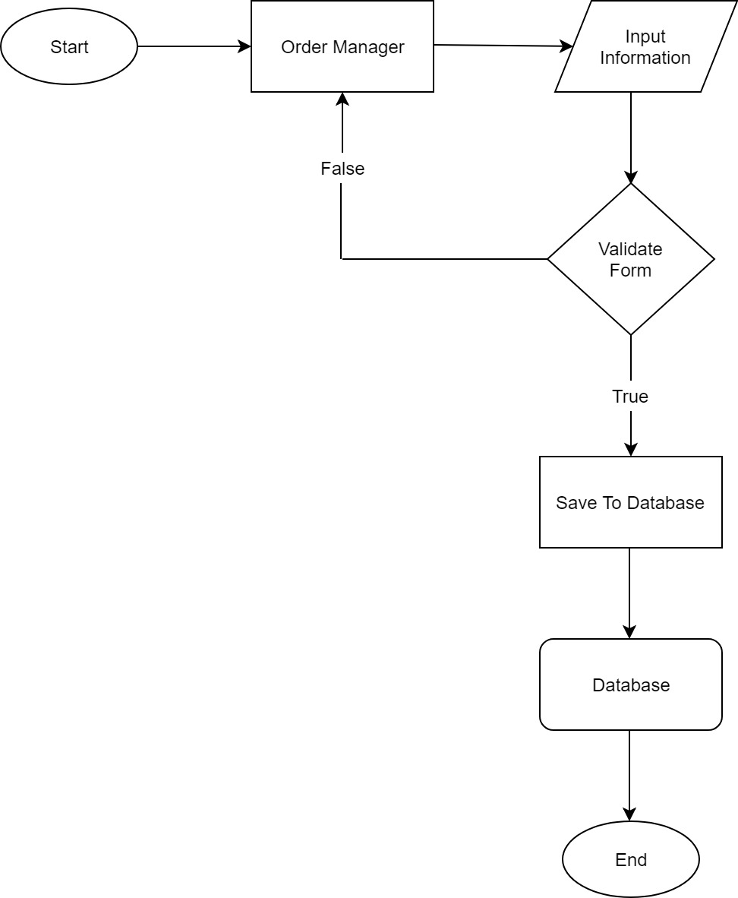**Create**

**B - Accounts department people:**

1. 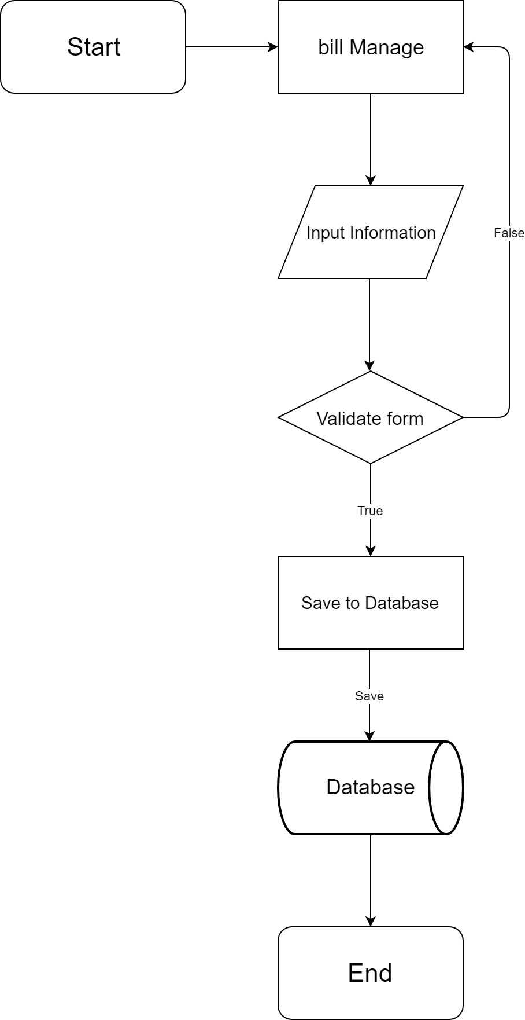**Bill**
2. **Create**
3. 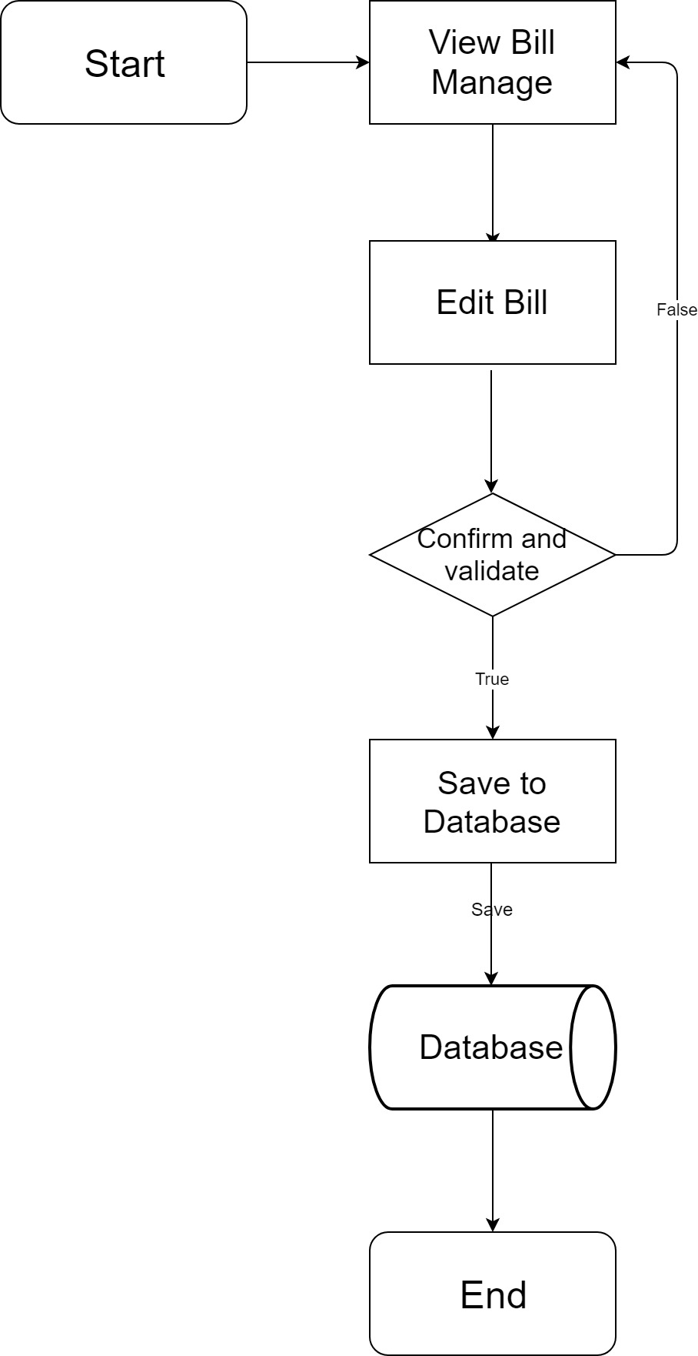**Edit**
4. **Search**

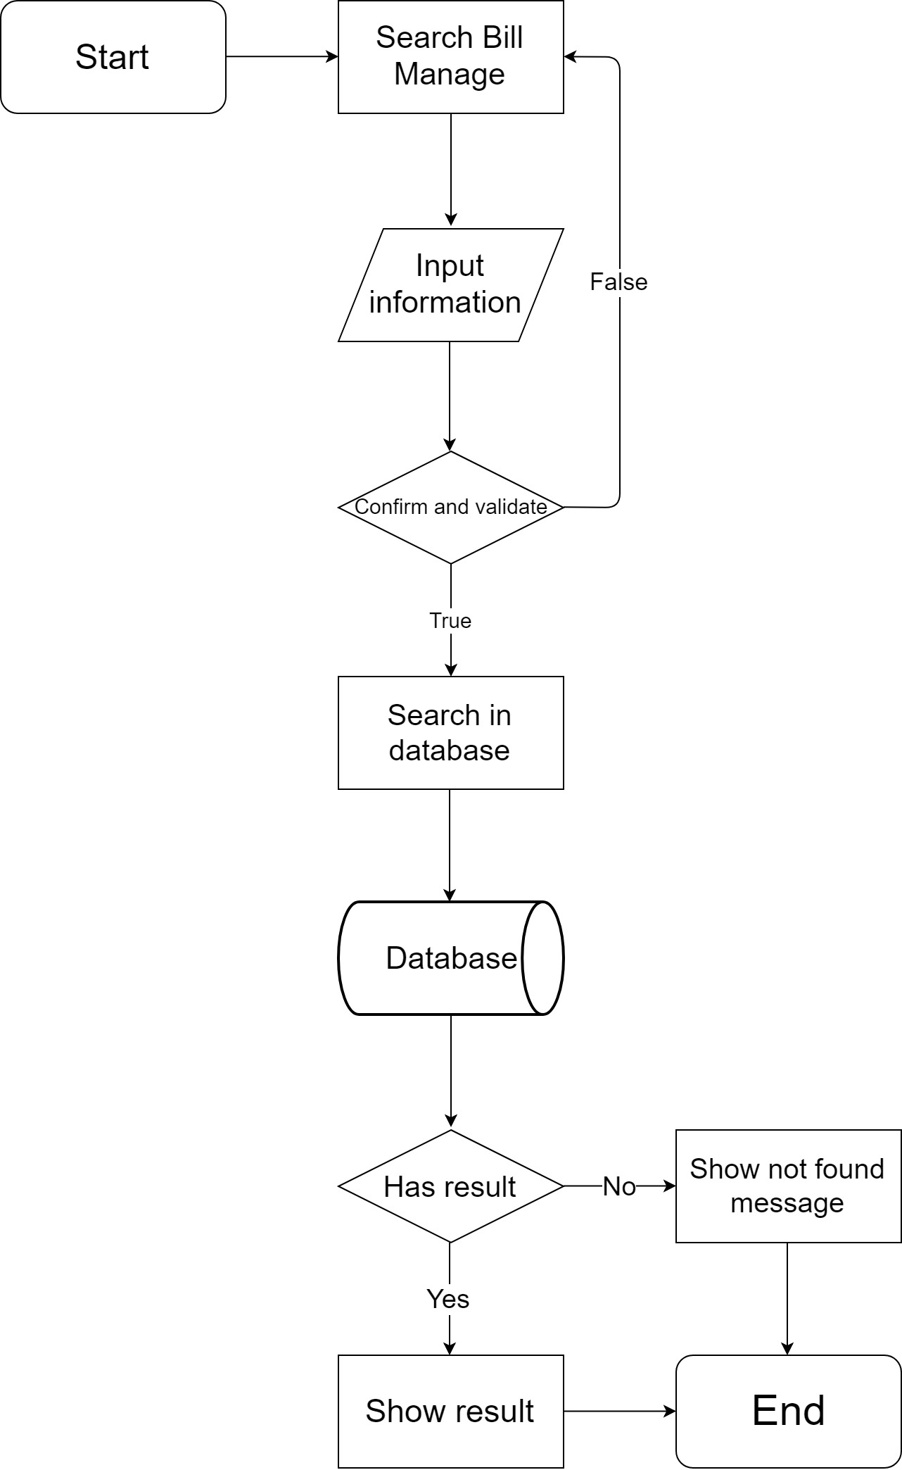

1. **Payment**
2. 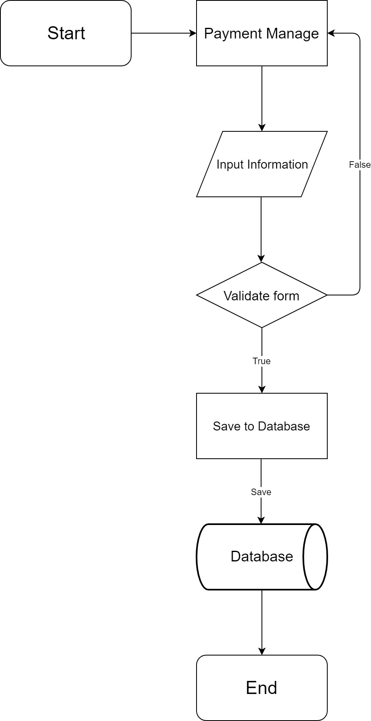**Create**
3. 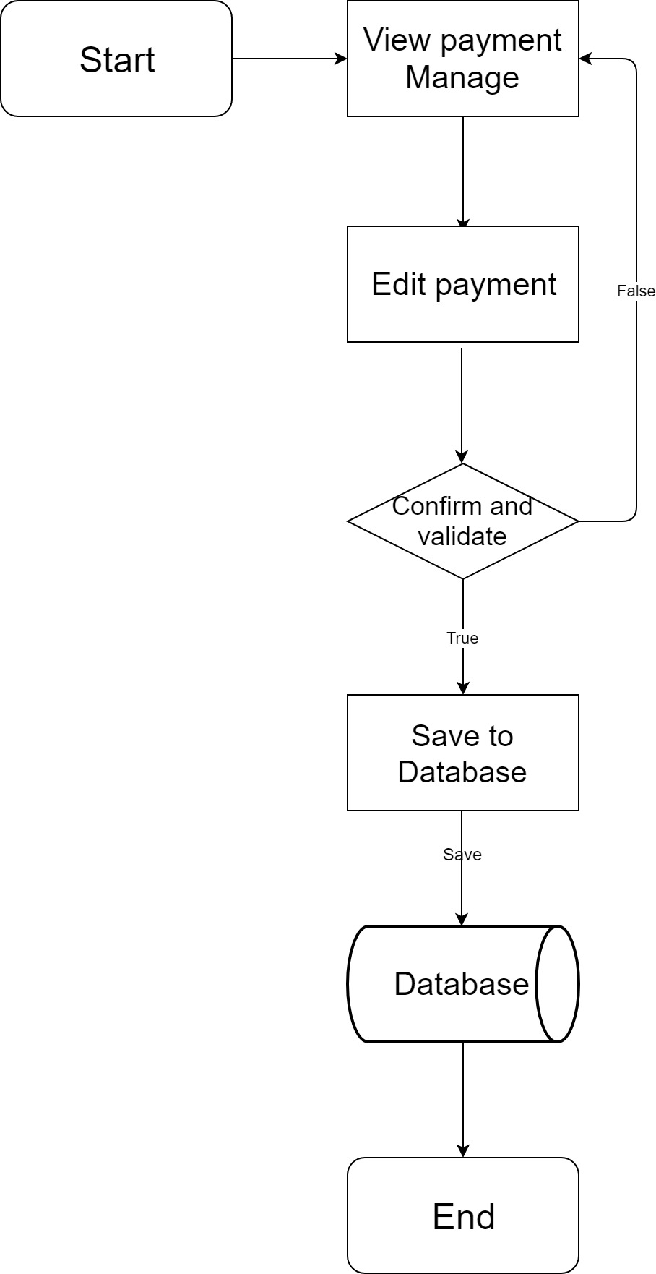**Edit, Update**
4. 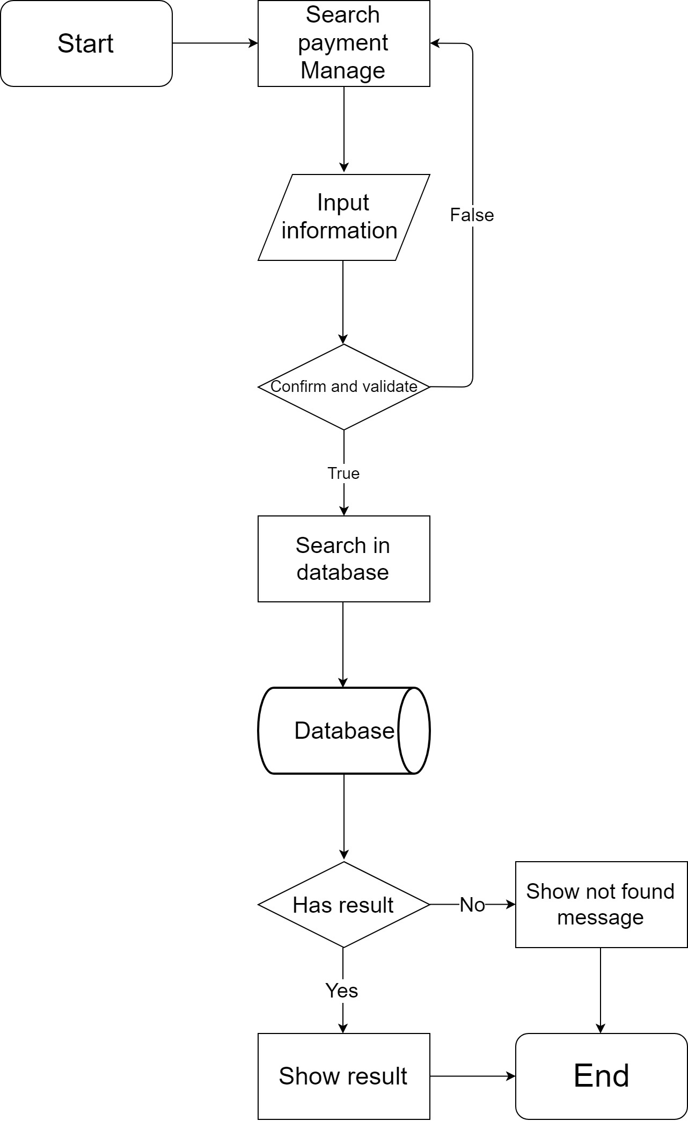**Search**

**C – Admins:**

1. 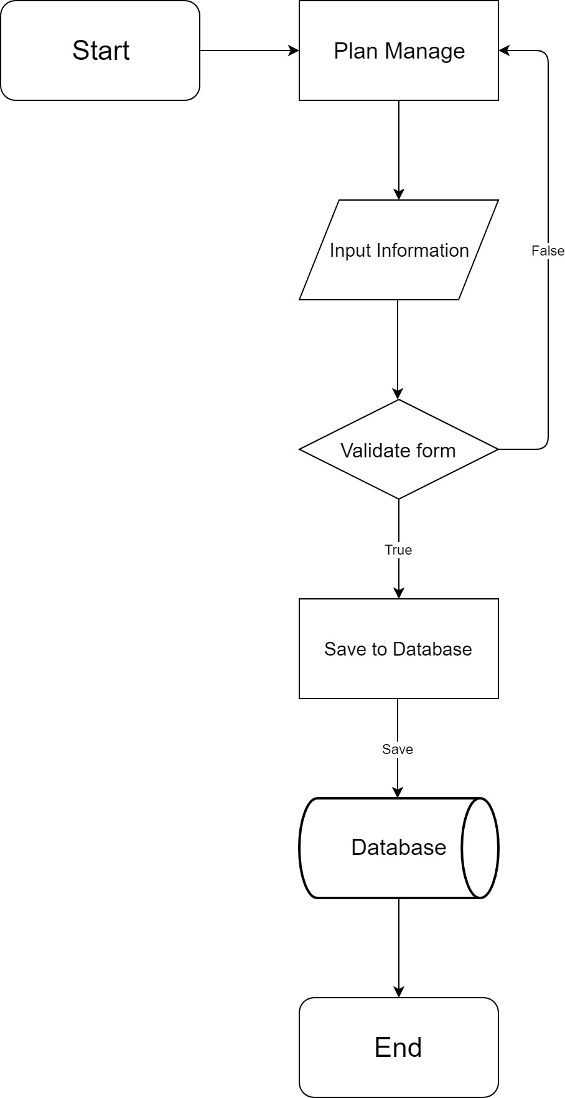**Plan**
2. **Create**
3. 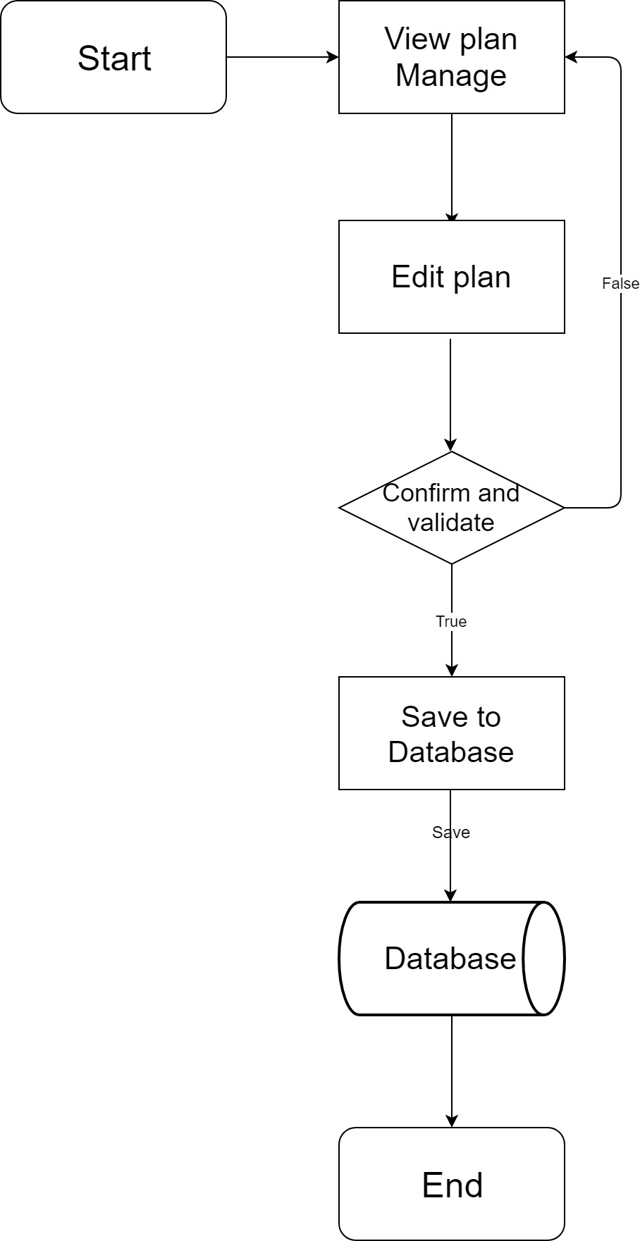**Edit, Update**
4. 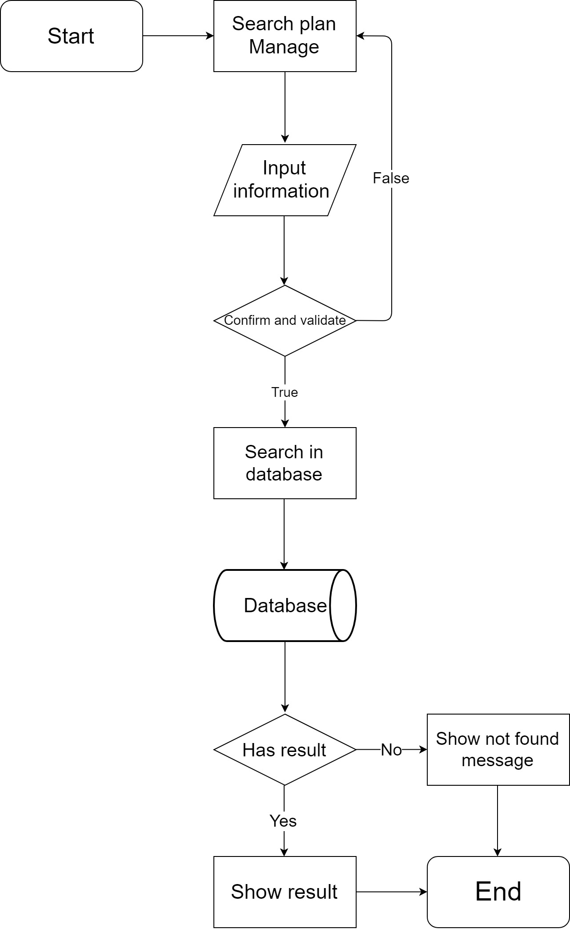**Search**
5. **Store**
6. 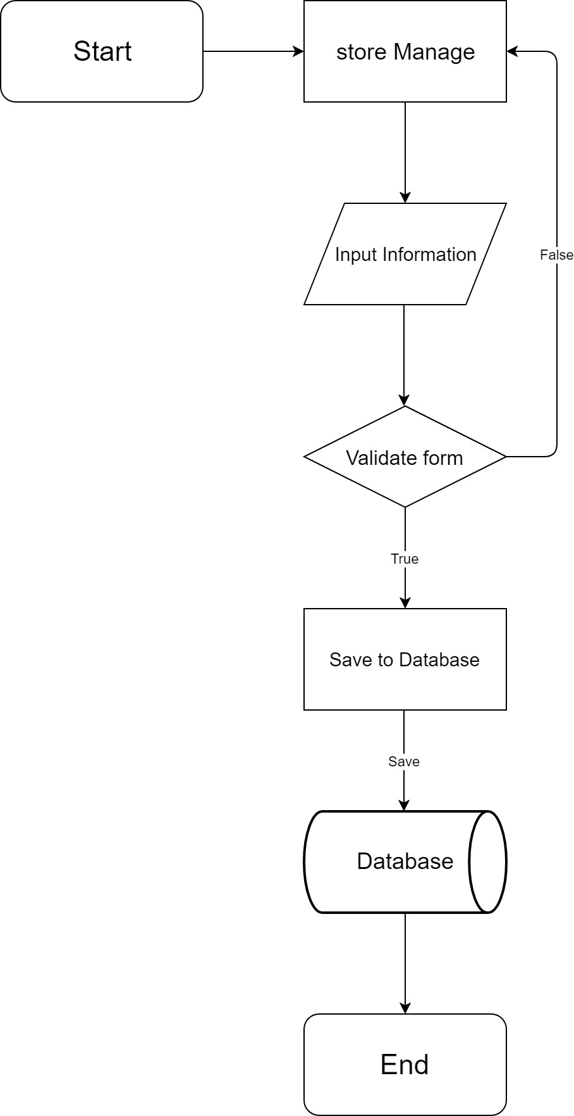**Create**
7. 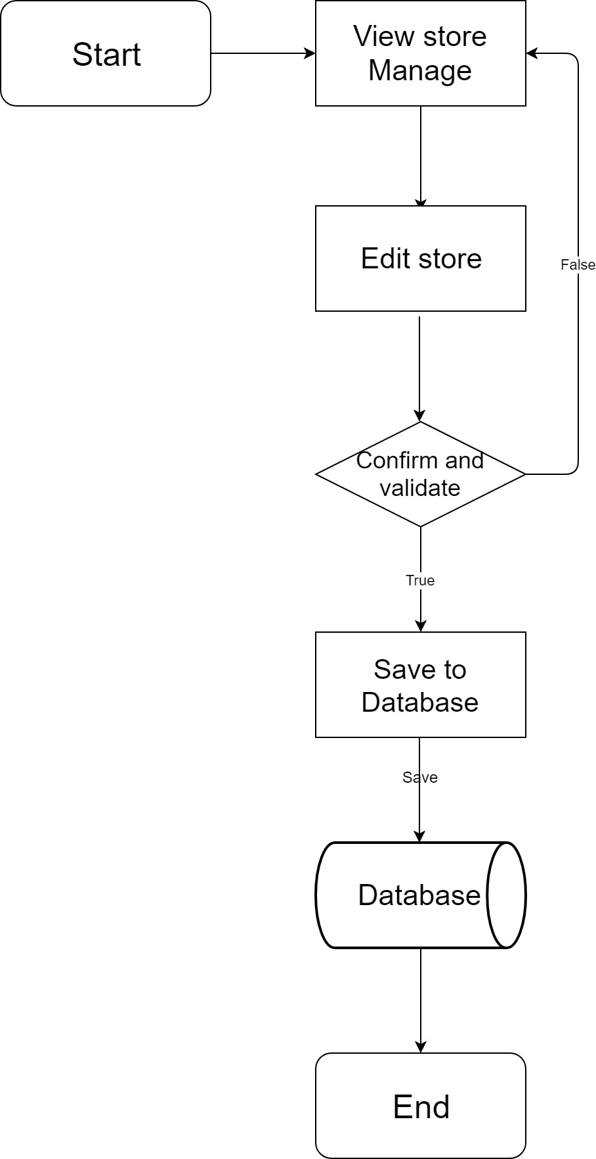**Edit, Update**
8. 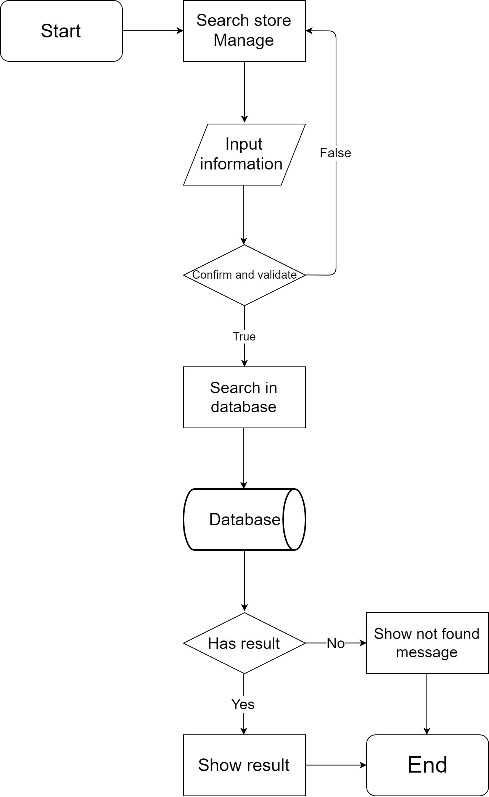**Search**
9. **Employee**
10. 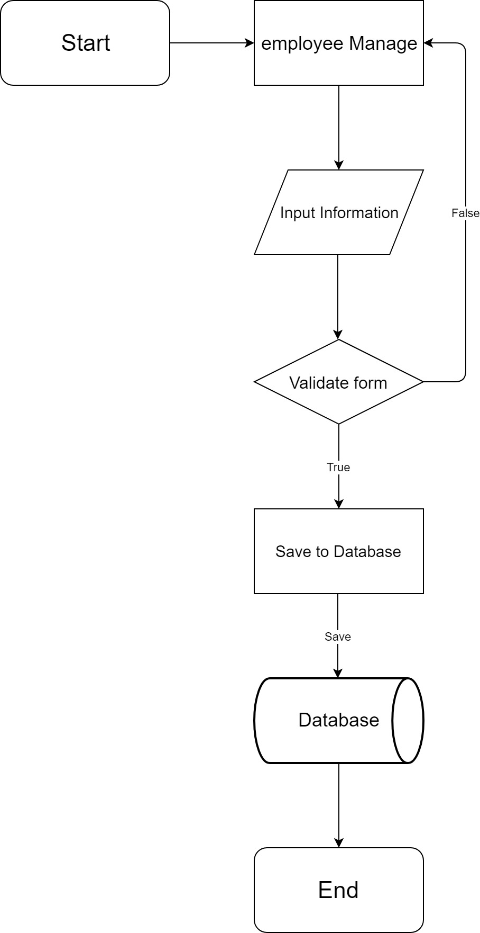**Create**
11. 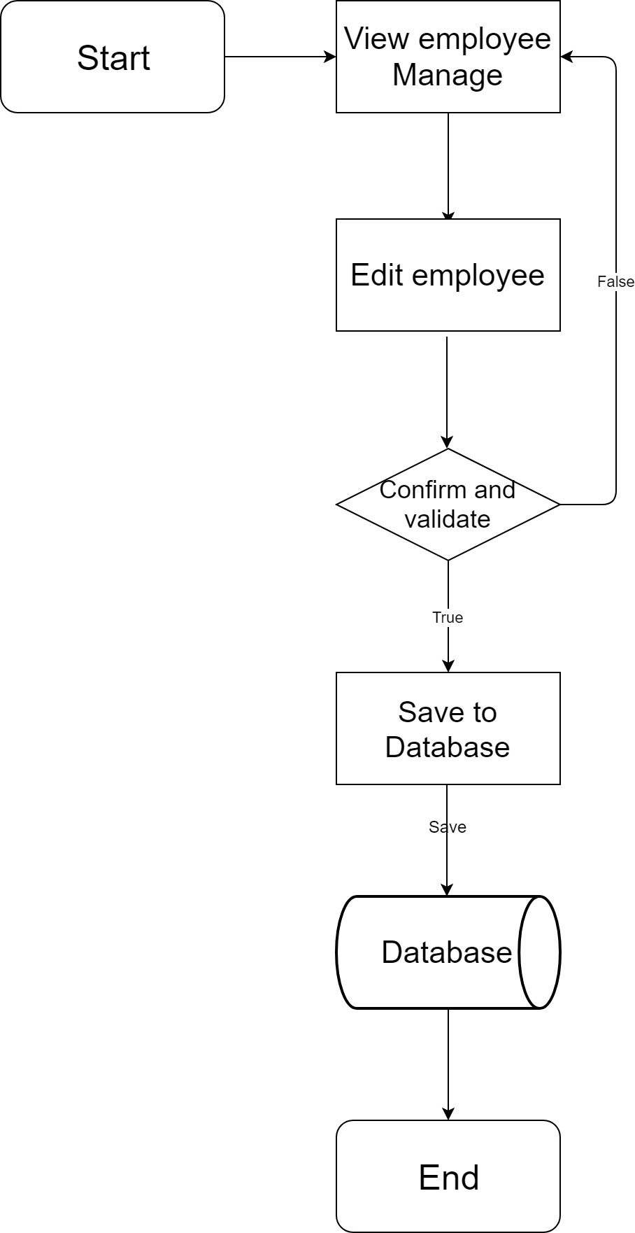**Edit, Update**
12. 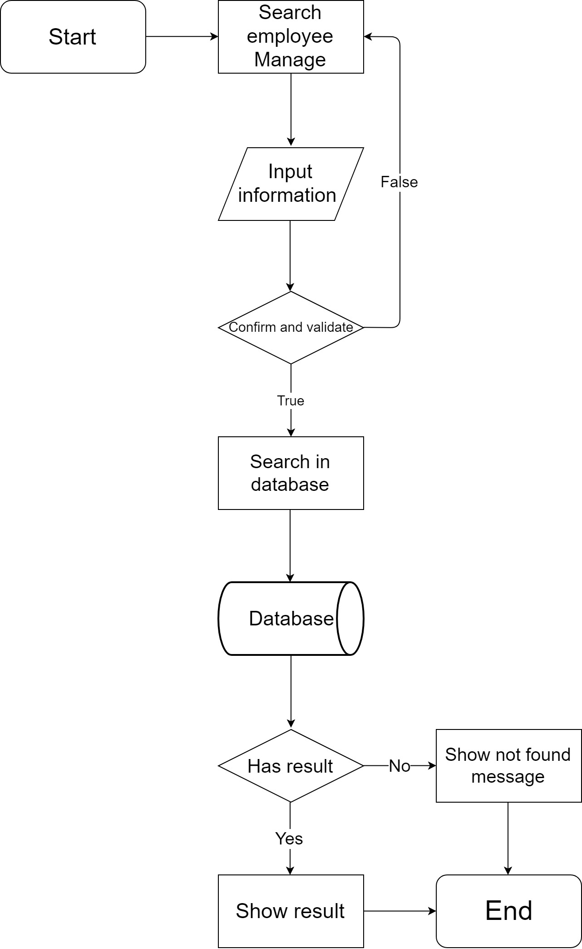**Search**
13. **Account**
14. 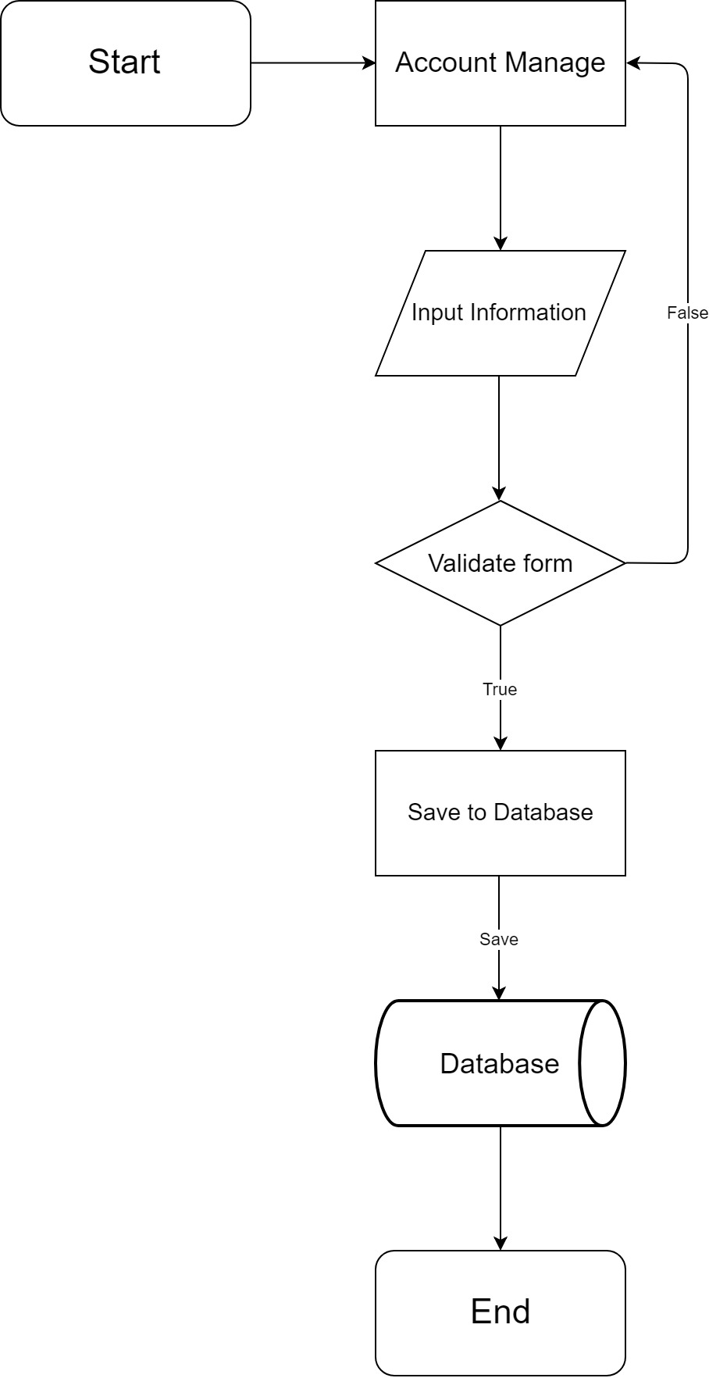**Create**
15. 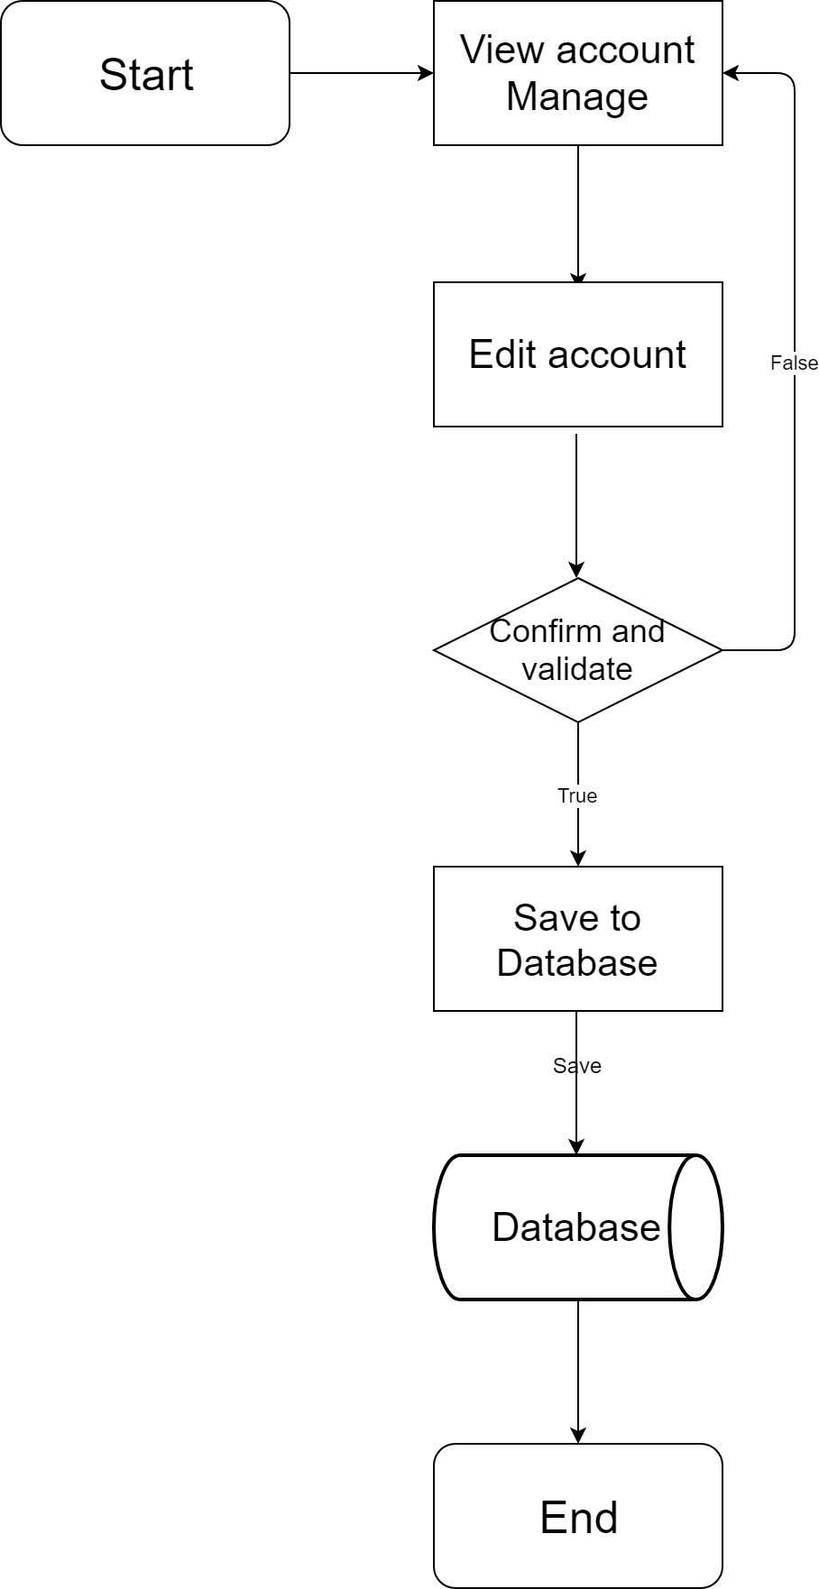**Edit, Update**
16. 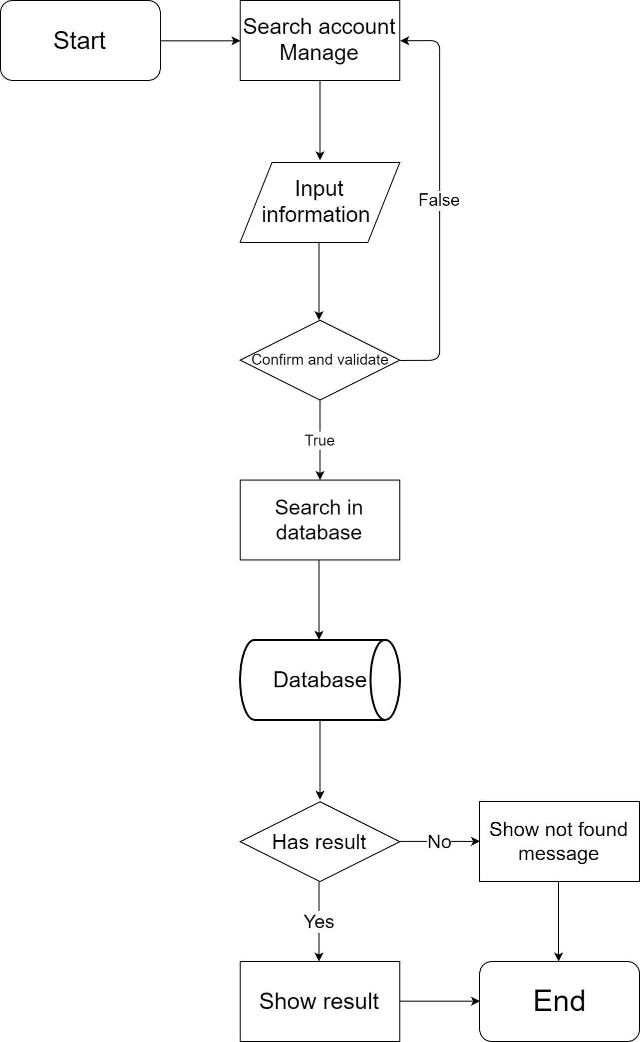**Search**

**D - Technical people:**

1. 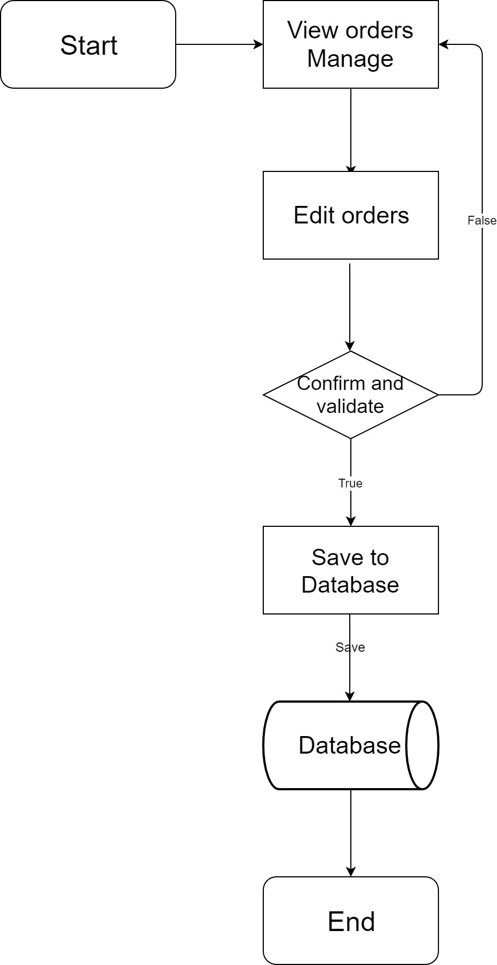**Orders**
2. **Edit, Update**
3. 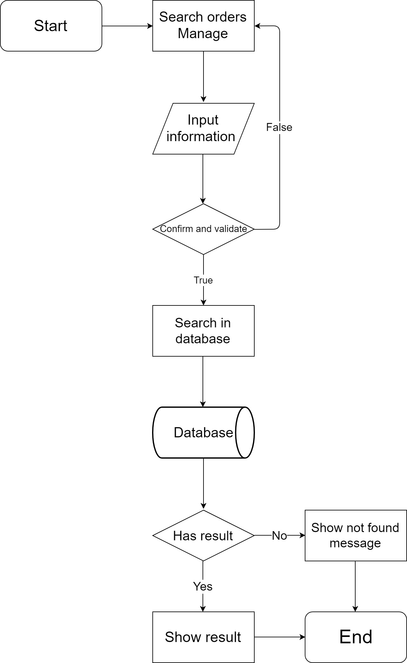**Search**
4. **Connection**
5. 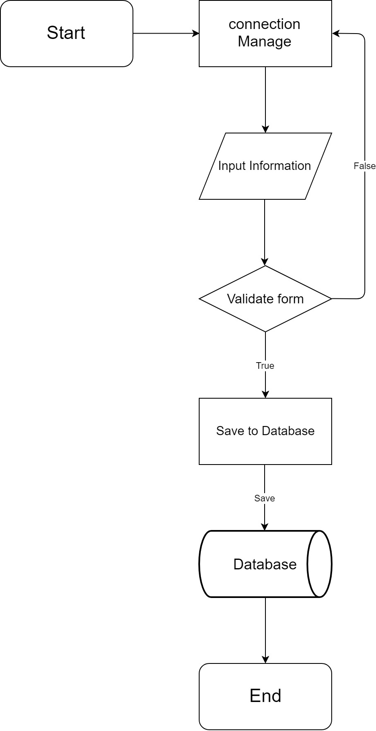**Create**
6. 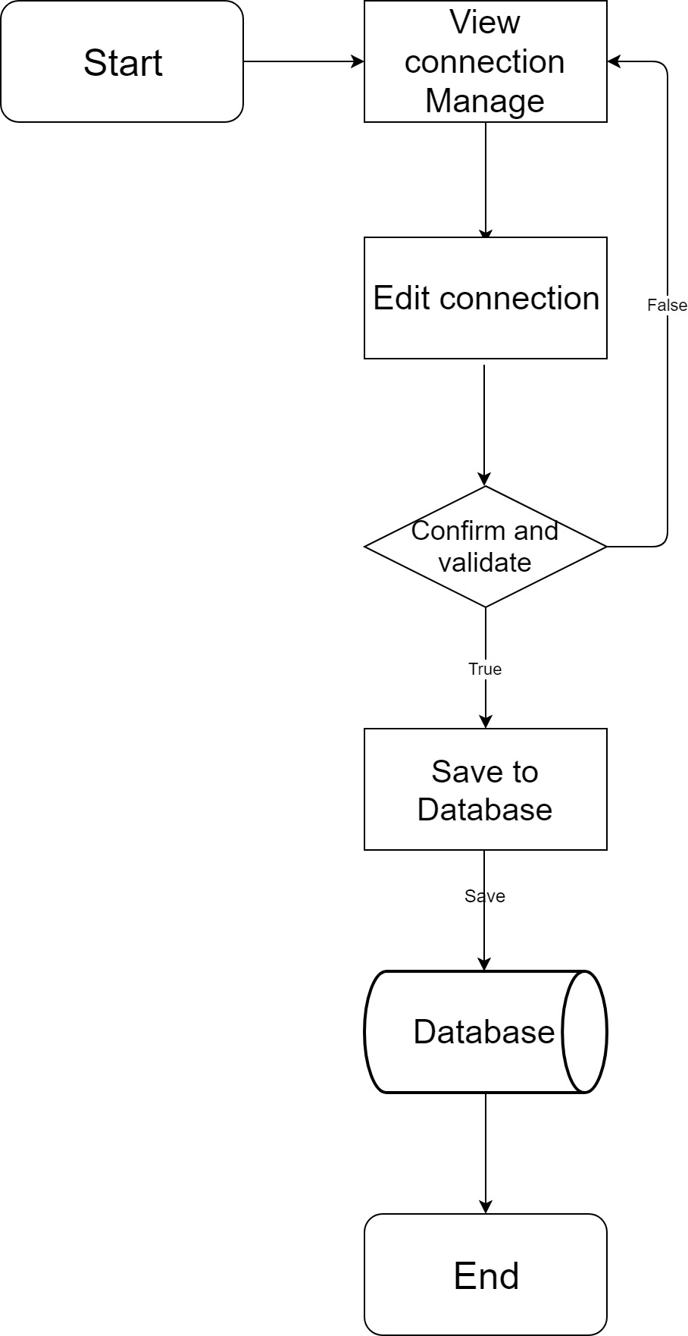**Edit, Update**
7. 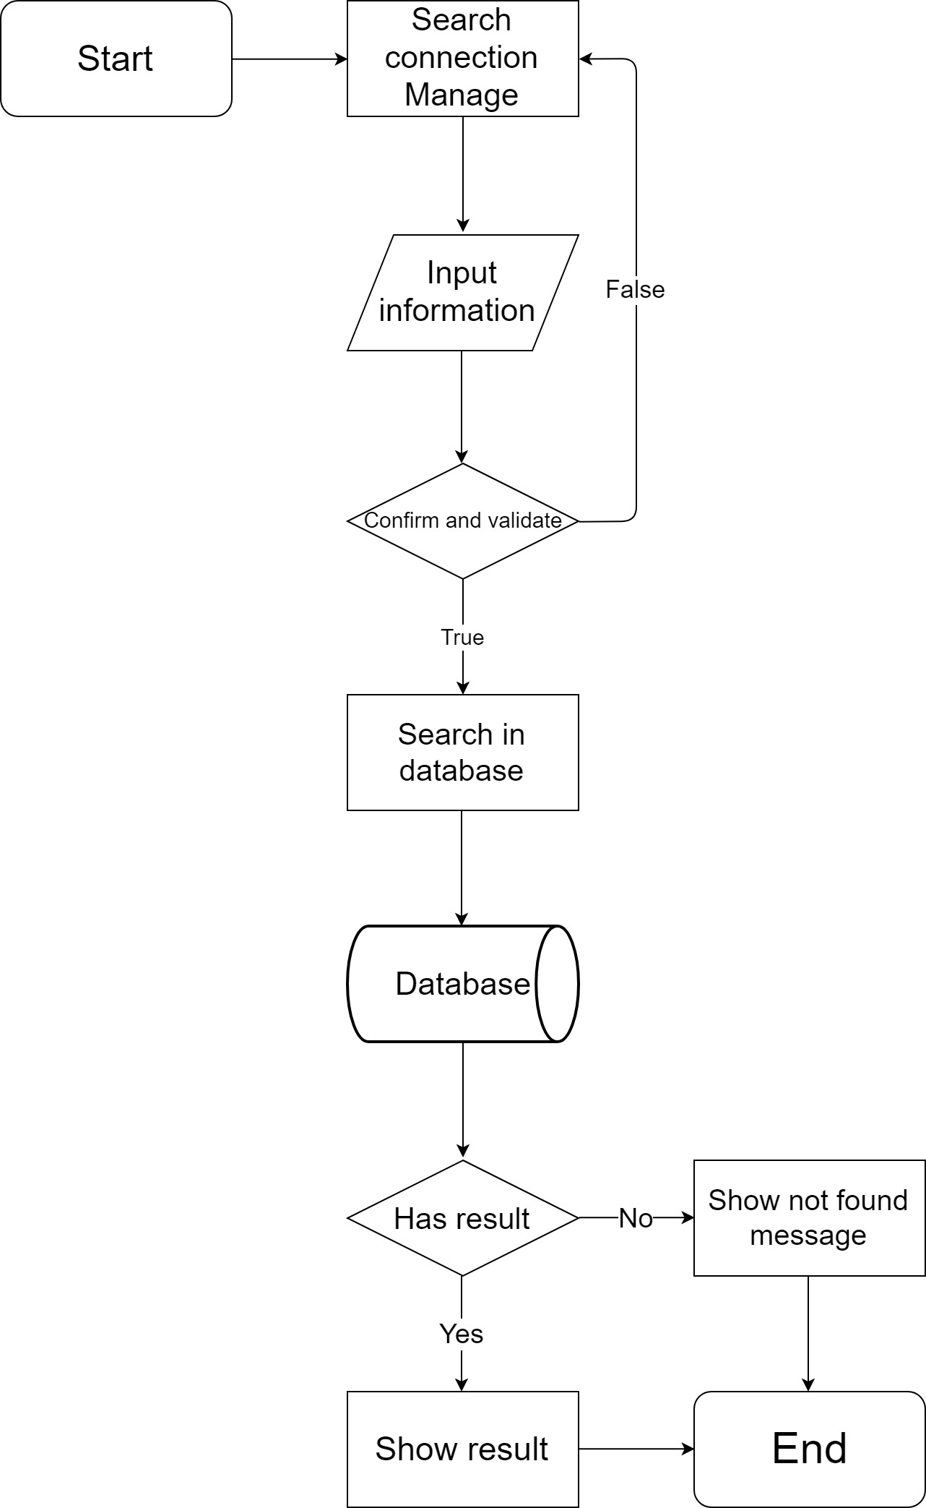**Search**
8. 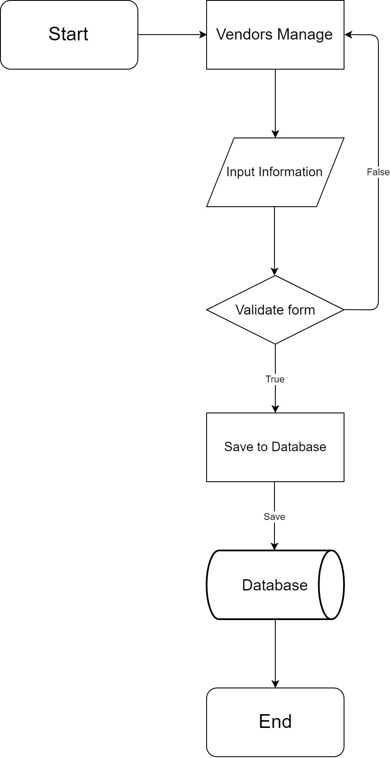**Vendors**
9. **Create**
10. 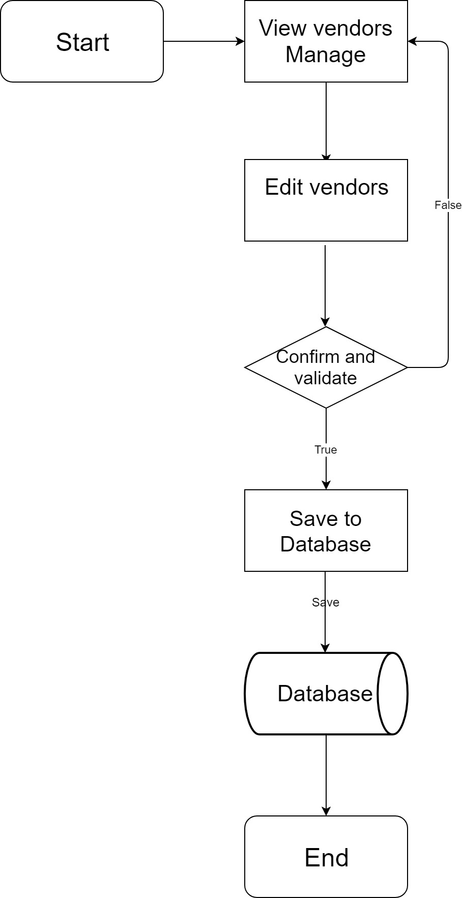**Edit, Update**
11. 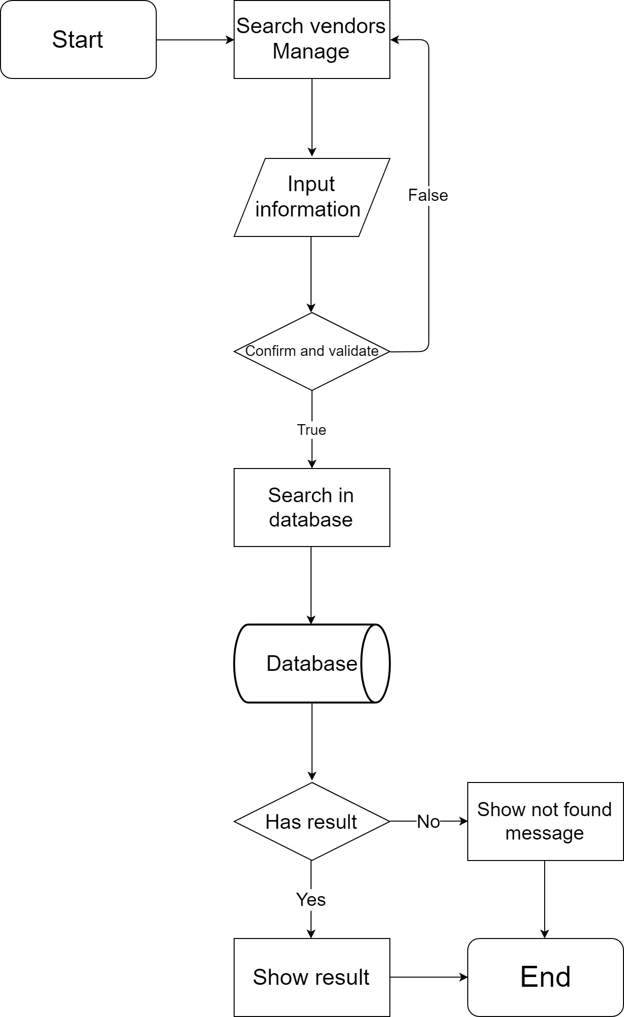**Search vendors**
12. **Device**
13. 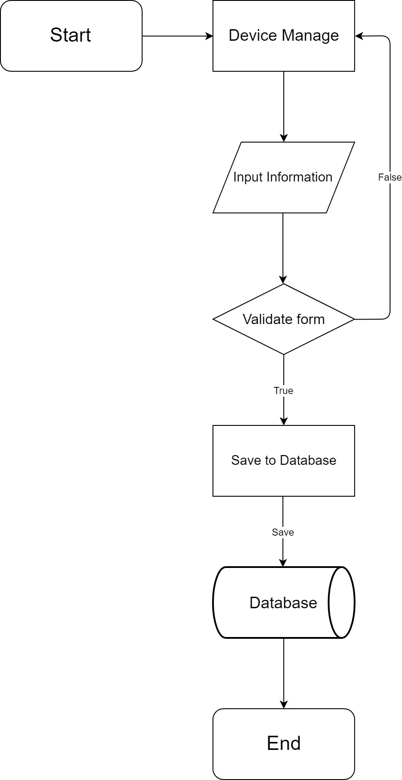**Create**
14. 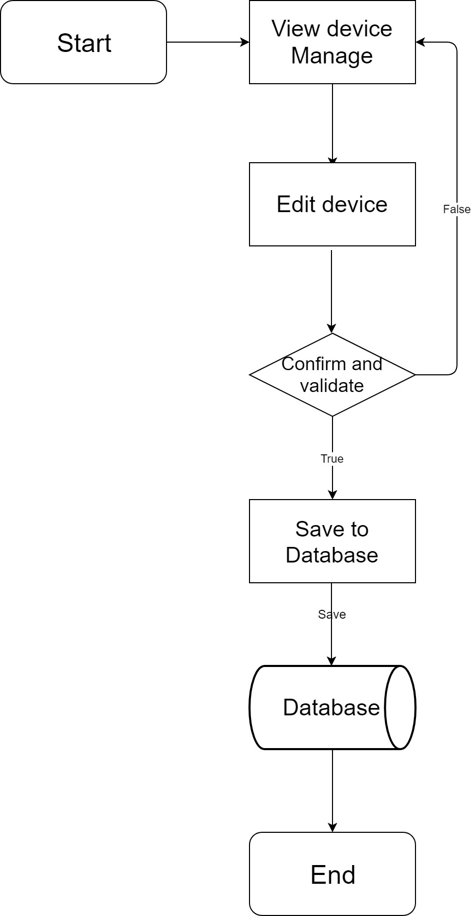**Edit, Update**
15. 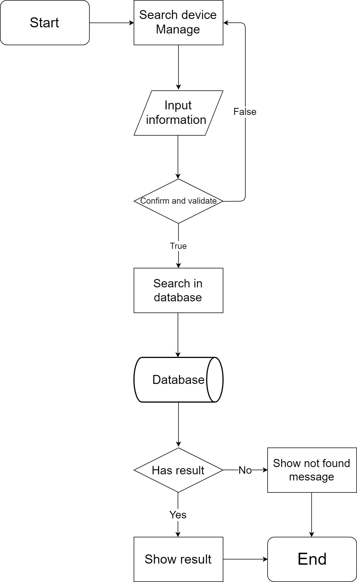**Search**
16. **Data flow diagram:**
17. **Context level diagram:**

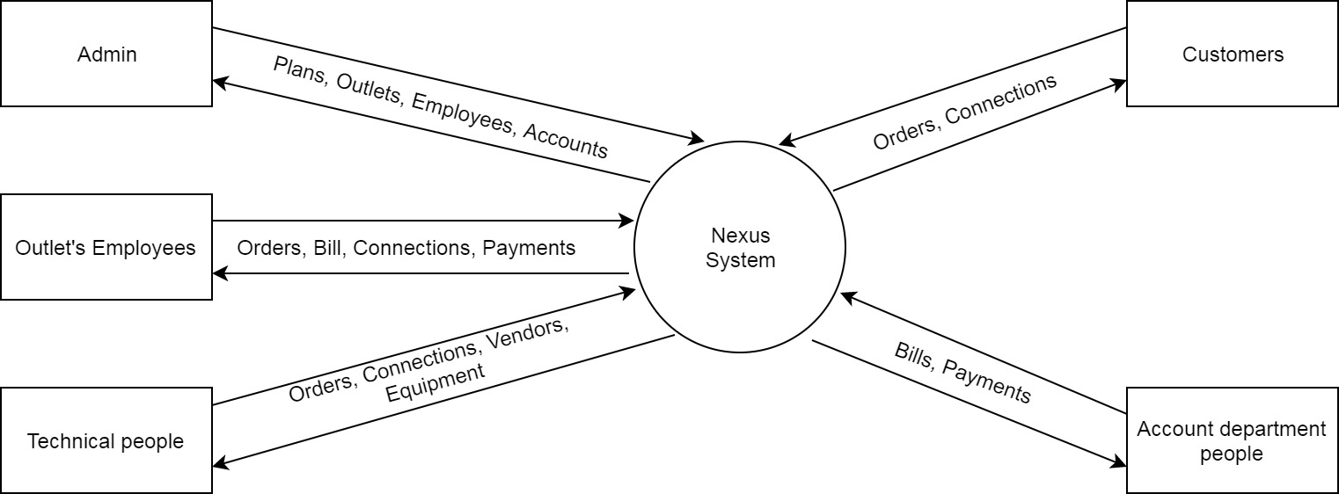

1. **Level 0 DFD:**

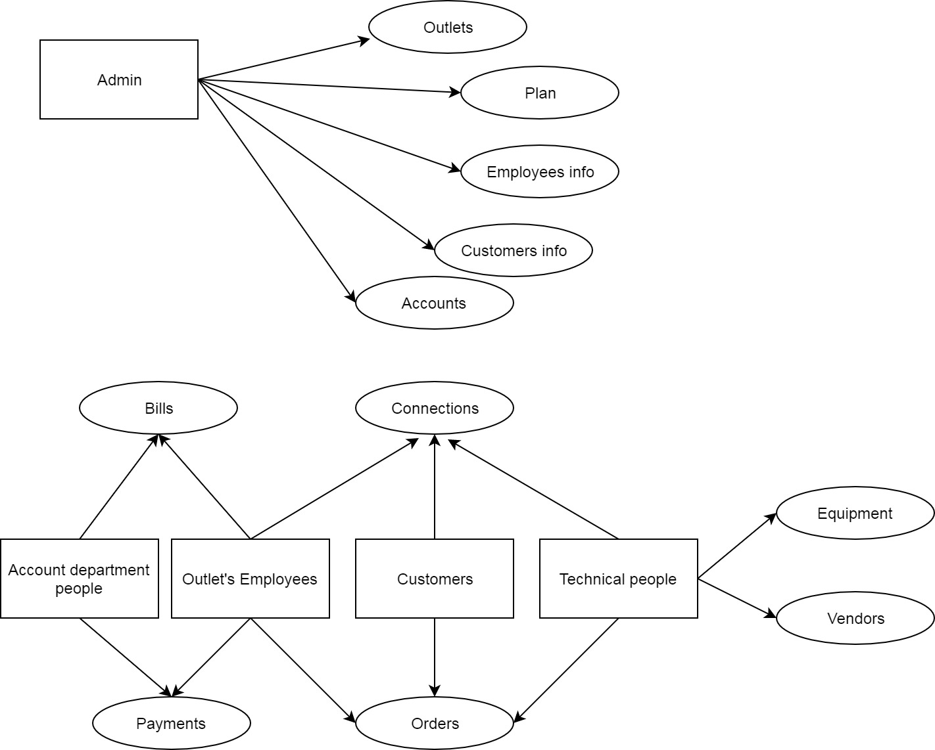

1. **Level 1 DFD:**

**Admin:**

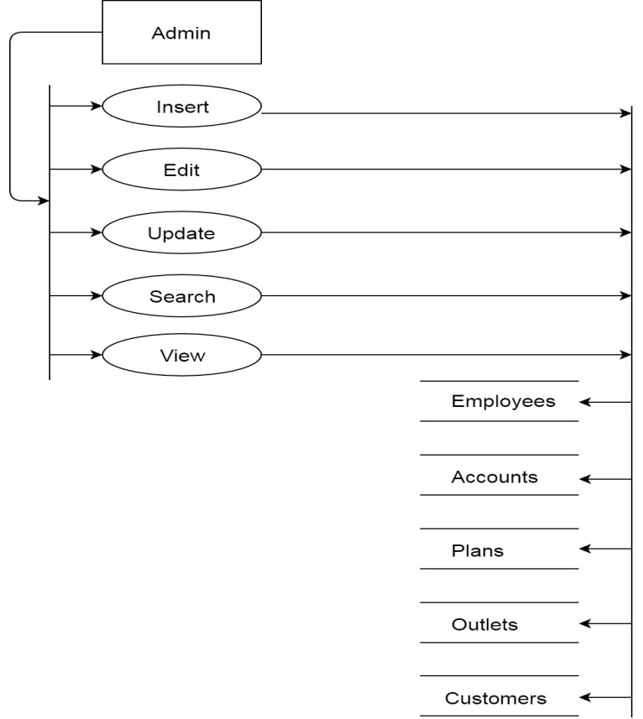

**Technical people:**

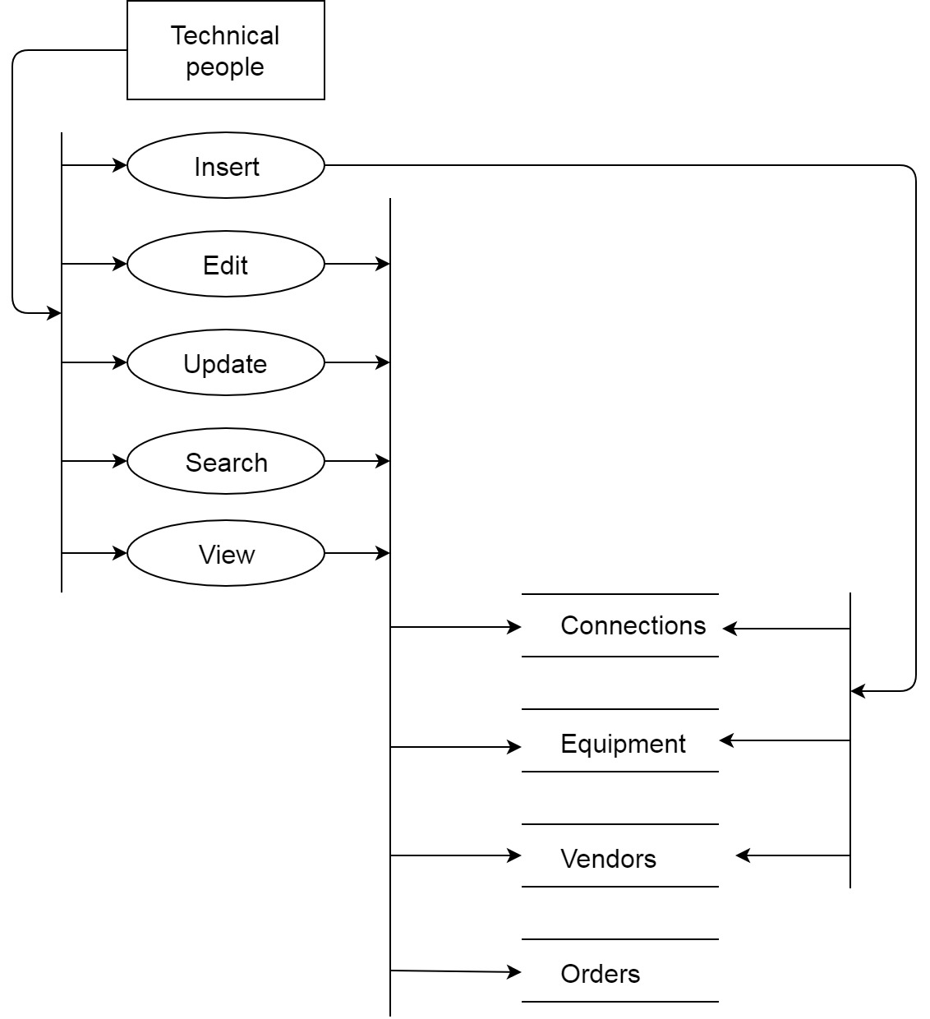

**Accounts department people:**

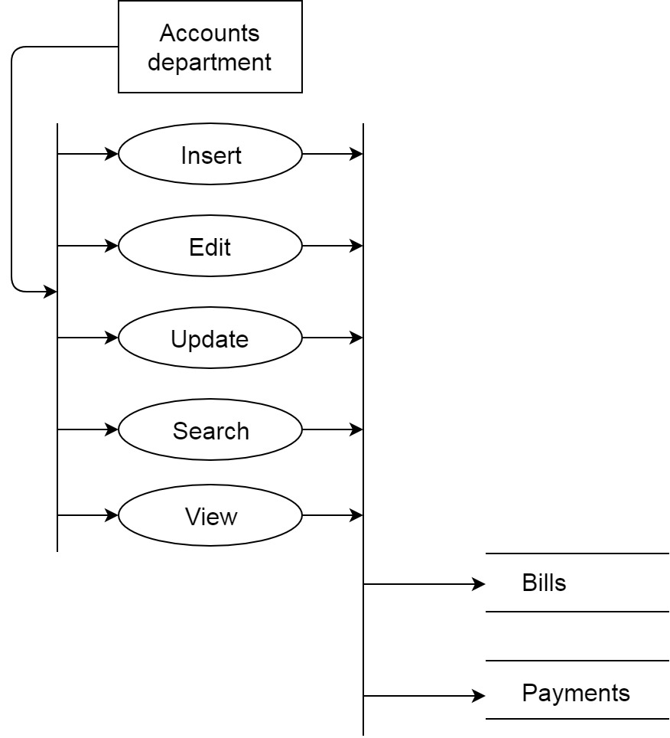

**Outlets employee:**

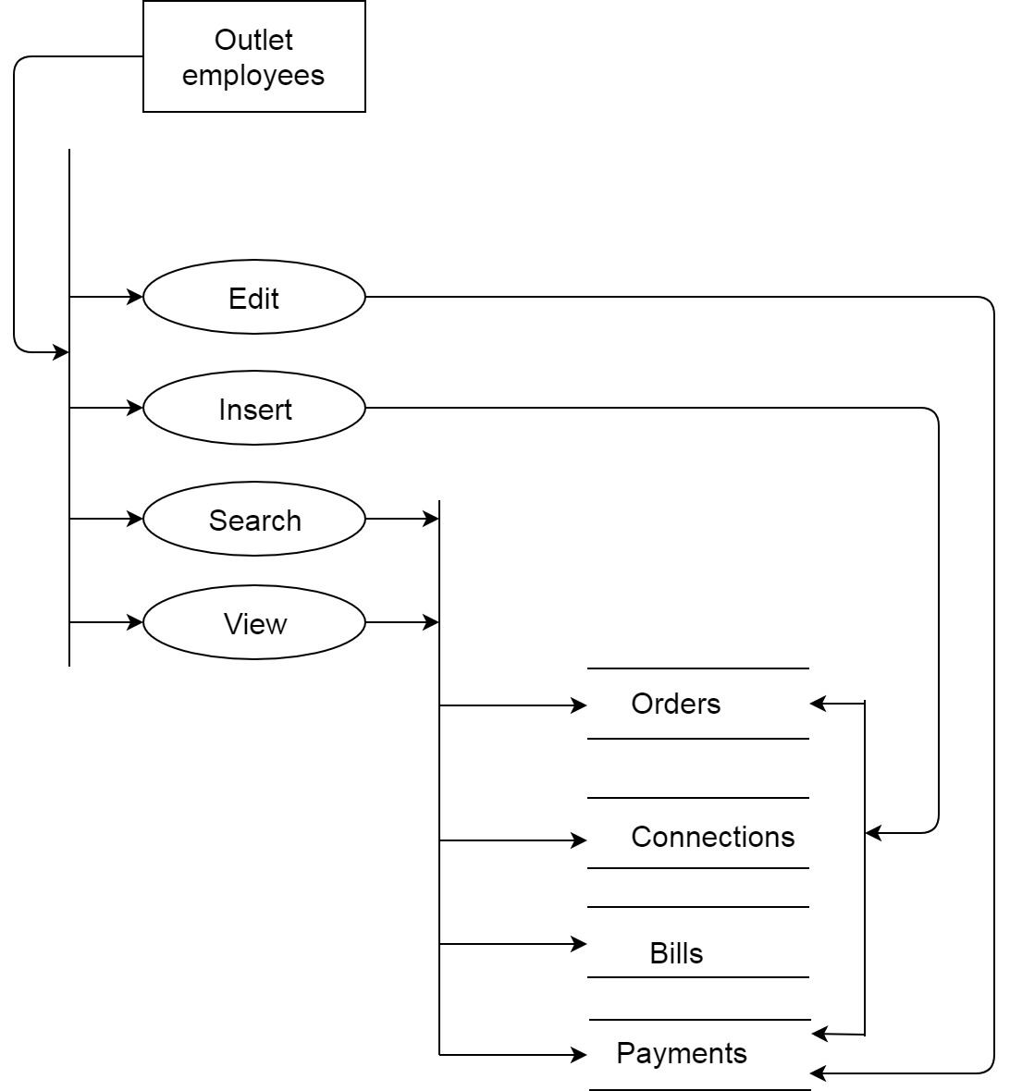

**Customers:**

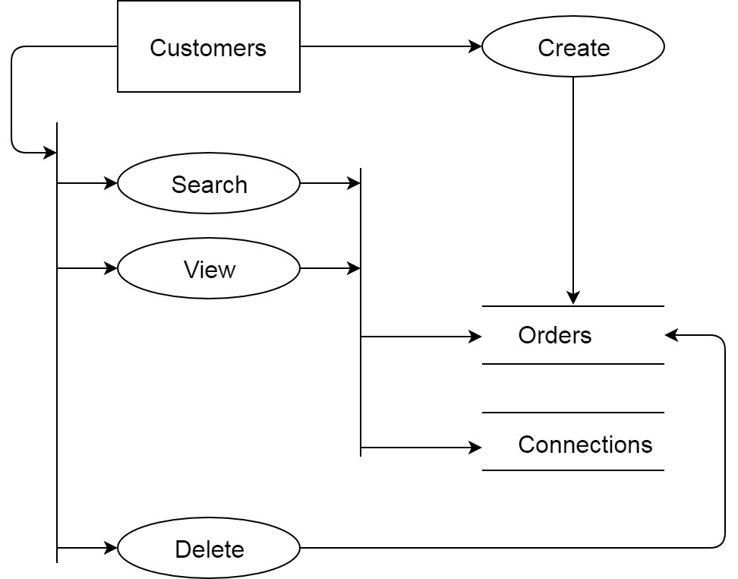

1. **Use case diagram:**

**Admin:**

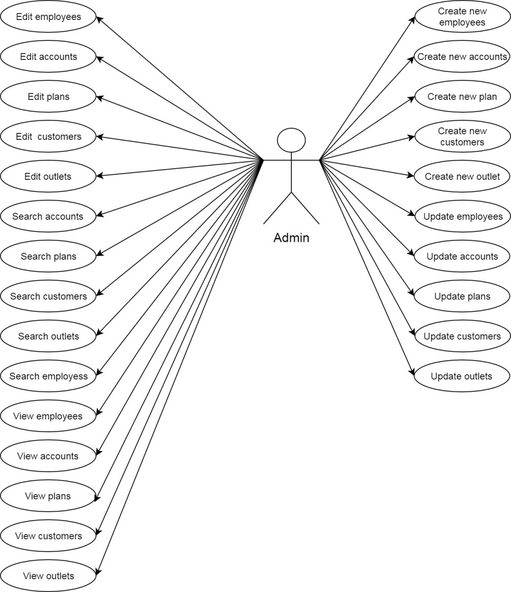

**Technical people:**

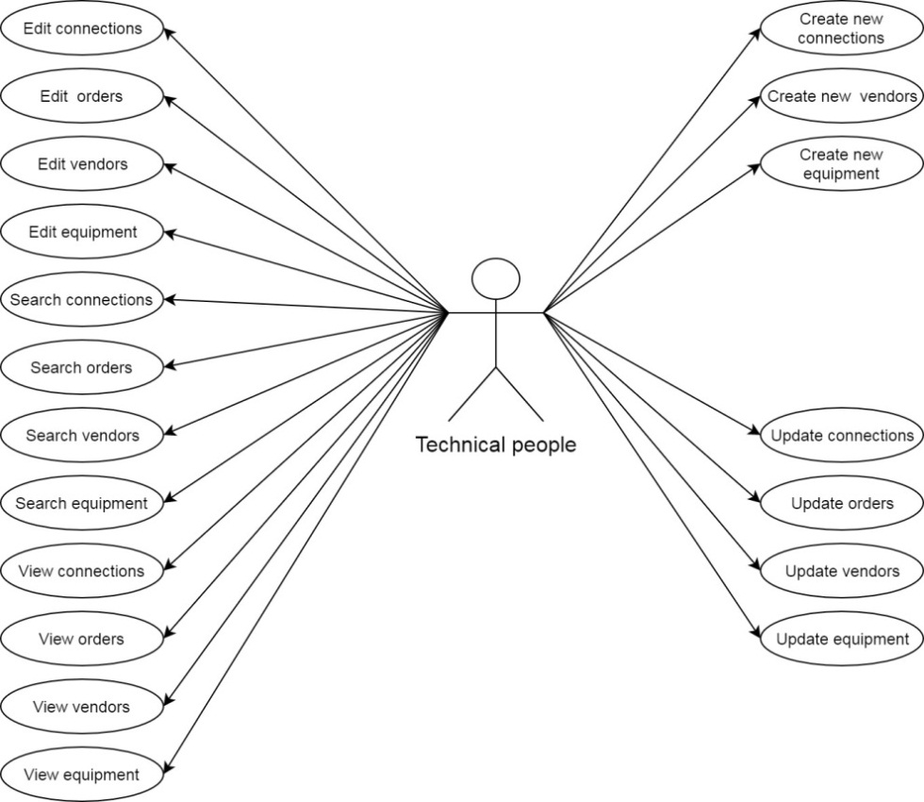

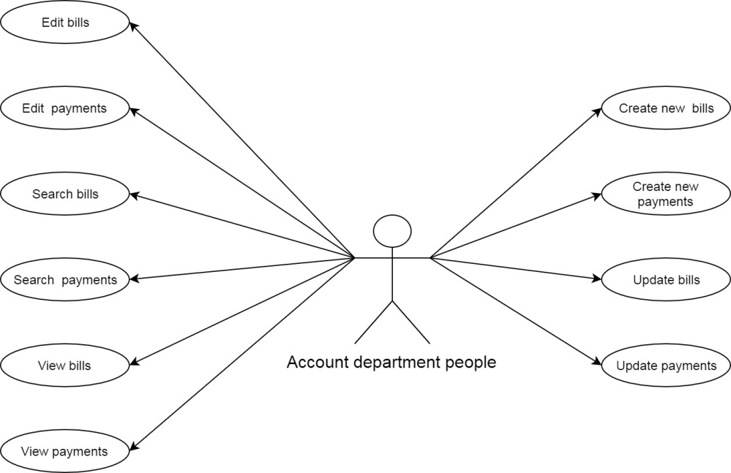**Accounts department people:**

**Outlets employee:**

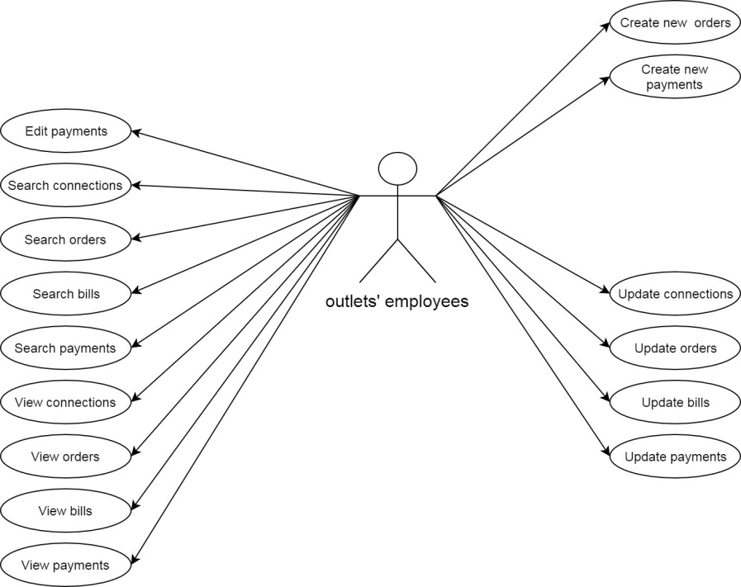

**Customers:**

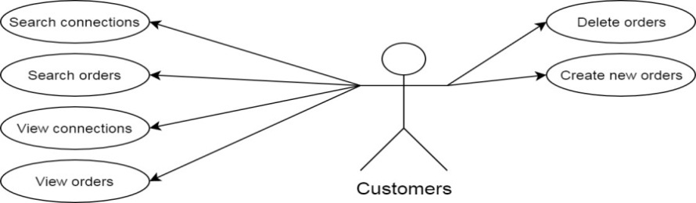

1. **Sequence diagram:**

**Login:**

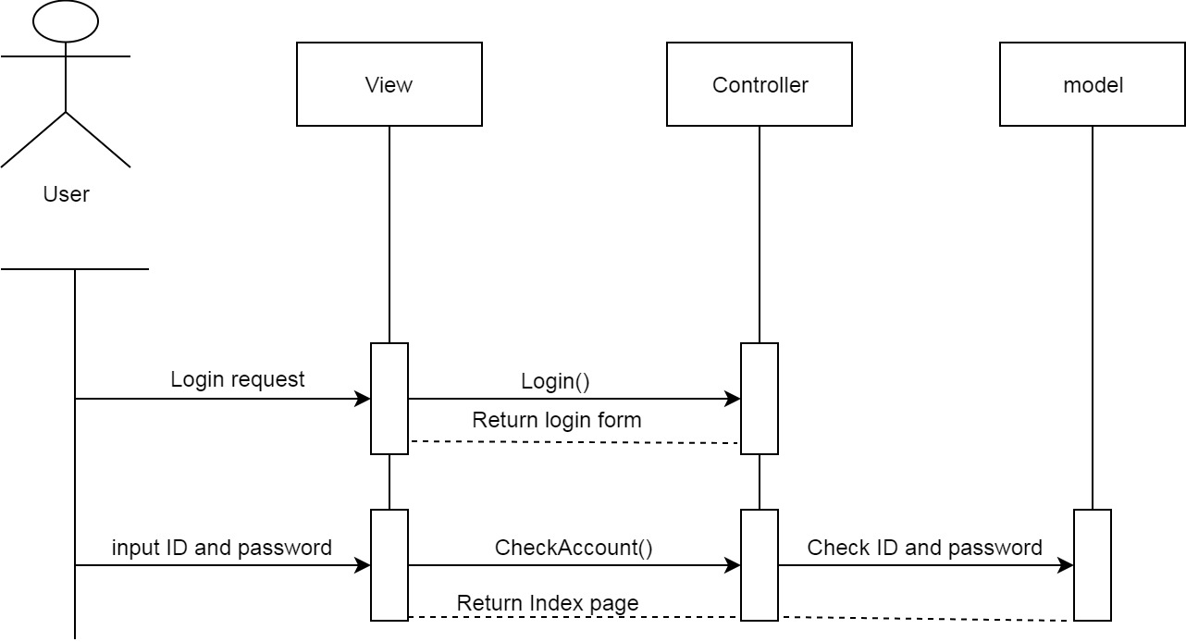

|  |  |  |
| --- | --- | --- |
| **Use case name** | Login | |
| **Actors** | Admin, Outlet’s employee, Technical and Accounts people, customer | |
| **Description** | Log in the system | |
| **Requirement** |  | |
| **Pre – condition** |  | |
| **Post – condition** |  | |
| **Basic flow** | **Actions:**  1.Users click on Login menu  3.Users enter username and password  4.Click “Login” button  [alternative] | **System response:**  2.Displays input form:  “Username” textfield  “Password” textfield  “Login” button  “Cancel” button  5.Validates input data  6.Logs into the system |
| **Alternative flow** | **Actions:**  [Alternative]  1.Users click “Cancel” button | **System reponse:**  2.Returns to home page |
| **Exception** | Actions:  [Exception 1]  1.Users enter invalid username and password | **System reponse:**  2.Shows error message |

|  |  |  |
| --- | --- | --- |
| **Use case name** | Logout | |
| **Actors** | Admin, Outlet’s employee, Technical and Accounts people, customer | |
| **Description** | Log out to the system | |
| **Requirement** |  | |
| **Pre – condition** | Already logged in the system | |
| **Post – condition** |  | |
| **Basic flow** | **Actions:**  1.Users click on Logout button  3.Users click “OK” button  [alternative] | **System reponse:**  2.Displays confirm message  4.Logs out the system |
| **Alternative flow** | **Actions:**  [Alternative]  1.Users click “Cancel” button | **System reponse:**  2.Returns to previous page |
| **Exception** |  |  |

**Logout:**

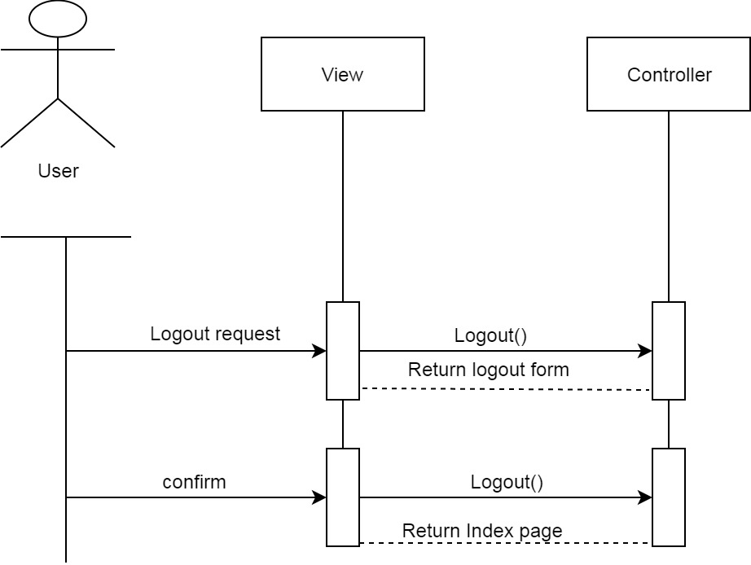

**Place order:**

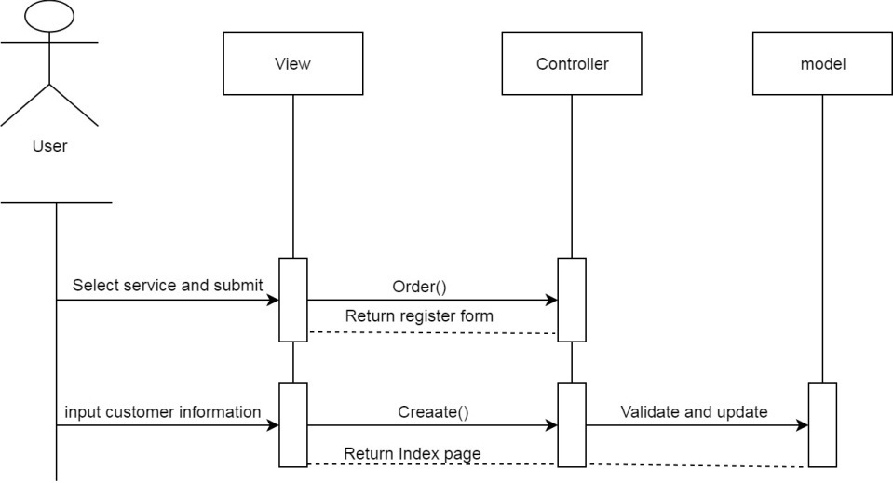

|  |  |  |
| --- | --- | --- |
| **Use case name** | Order | |
| **Actors** | Outlet’s employee, customer | |
| **Description** | Place order for connection | |
| **Requirement** |  | |
| **Pre – condition** | Already logged in the system (for employees) | |
| **Post – condition** |  |  |
| **Basic flow** | **Actions:**  1.Users click on “Order” button  3.Users enter data  4.Users click “Order” button  [alternative] | **System reponse:**  2.Displays customer information form.  5.Validates input data  6.Create order |
| **Alternative flow** | **Actions:**  [Alternative]  1.Users click “Cancel” button | **System reponse:**  2.Returns to previous page |
| **Exception** | Actions:  [Exception 1]  1.Users enter invalid data | 2.Shows error message |

**Insert:**

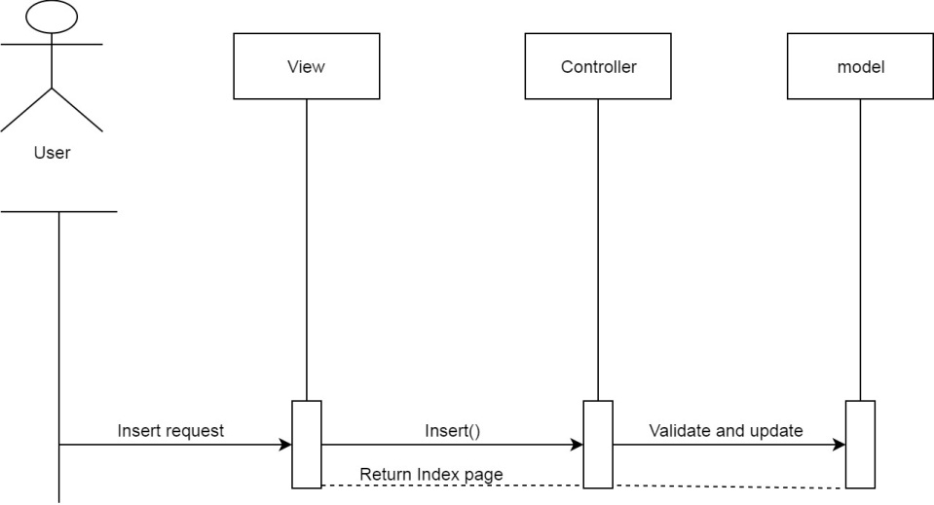

|  |  |  |
| --- | --- | --- |
| **Use case name** | Insert | |
| **Actors** | Admin, Outlet’s employee, Technical and Accounts people | |
| **Description** | Insert new items | |
| **Requirement** |  | |
| **Pre – condition** | Already logged in the system | |
| **Post – condition** |  |  |
| **Basic flow** | **Actions:**  1.Users click on “Insert” button  3.Users enter data  4.Users click “Order” button  [alternative] | **System reponse:**  2.Displays fill in form.  5.Validates input data  6.Create order |
| **Alternative flow** | **Actions:**  [Alternative]  1.Users click “Cancel” button | **System reponse:**  2.Returns to previous page |
| **Exception** | Actions:  [Exception 1]  1.Users enter invalid data | 2.Shows error message |

**Update:**

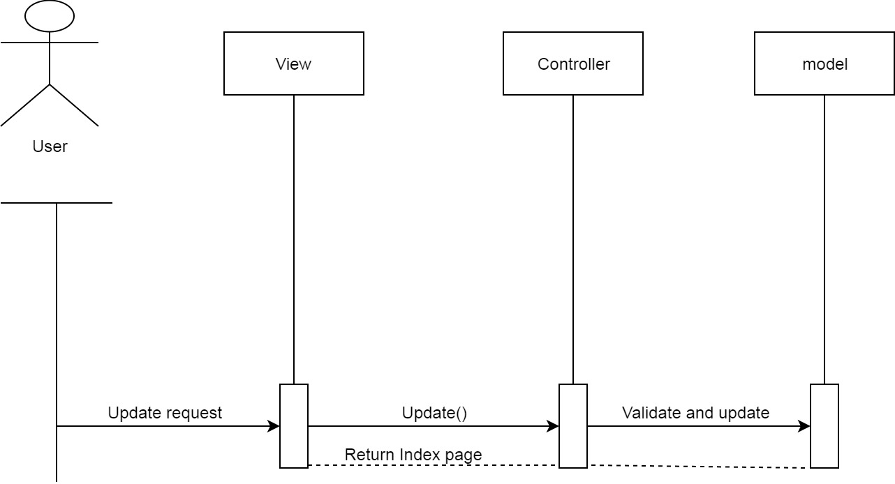

|  |  |  |
| --- | --- | --- |
| **Use case name** | Update | |
| **Actors** | Admin, Outlet’s employee, Technical and Accounts people | |
| **Description** | Update existing items | |
| **Requirement** |  | |
| **Pre – condition** | Already logged in the system | |
| **Post – condition** |  |  |
| **Basic flow** | **Actions:**  1.Users click on “Update” button  3.Users click “ok ” button  [alternative] | **System reponse:**  2.Displays confirm message.  4.Update record |
| **Alternative flow** | **Actions:**  [Alternative]  1.Users click “Cancel” button | **System reponse:**  2.Returns to previous page |
| **Exception** |  |  |

**Edit:**

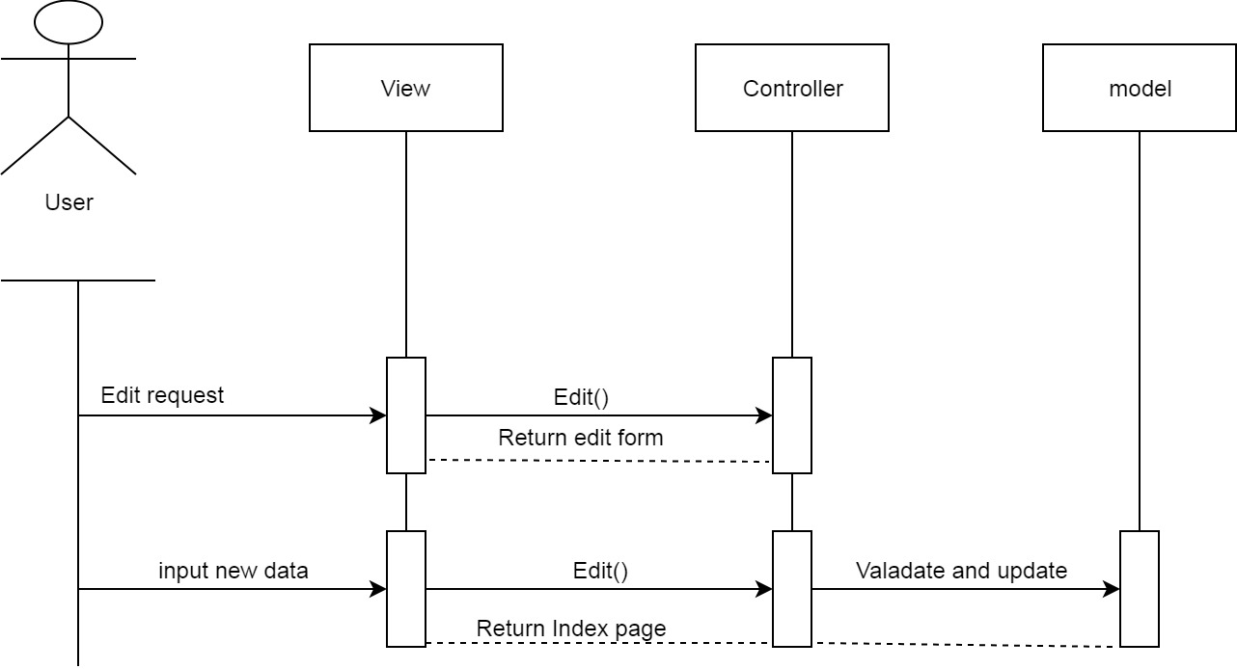

|  |  |  |
| --- | --- | --- |
| **Use case name** | Edit | |
| **Actors** | Admin, Outlet’s employee, Technical and Accounts people | |
| **Description** | Edit existing items | |
| **Requirement** |  | |
| **Pre – condition** | Already logged in the system | |
| **Post – condition** |  |  |
| **Basic flow** | **Actions:**  1.Users click on “Edit” button  3.Users enter new data  [alternative] | **System reponse:**  2.Displays fill in form.  4.Update record |
| **Alternative flow** | **Actions:**  [Alternative]  1.Users click “Cancel” button | **System reponse:**  2.Returns to previous page |
| **Exception** | Actions:  [Exception 1]  1.Users enter invalid data | 2.Shows error message |

1. **Entity – Relationship design:**

**Entities relationship diagram:**

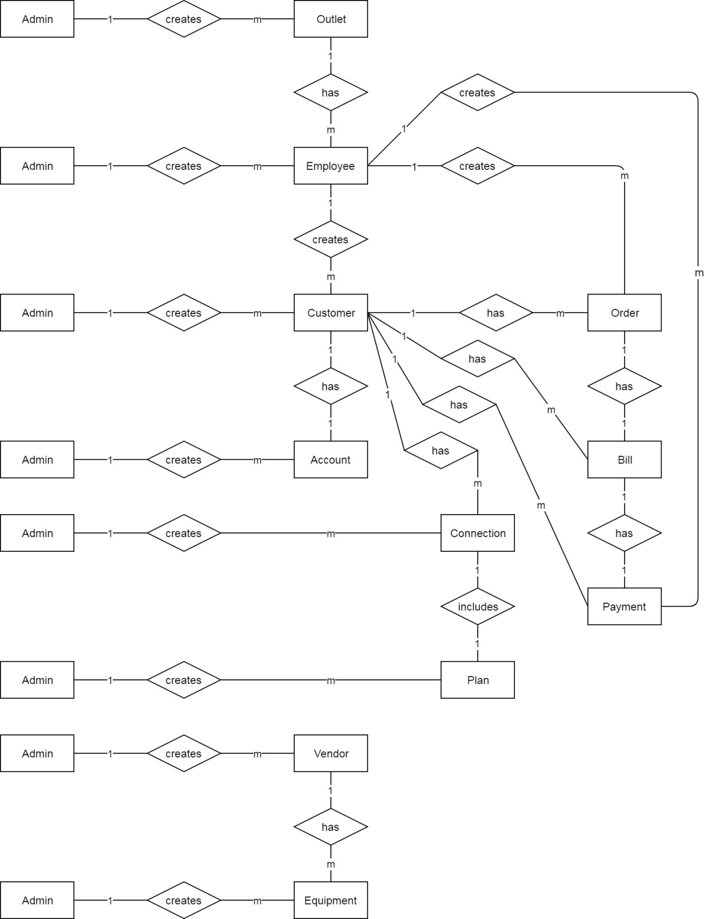

1. **Entities Attributes:**

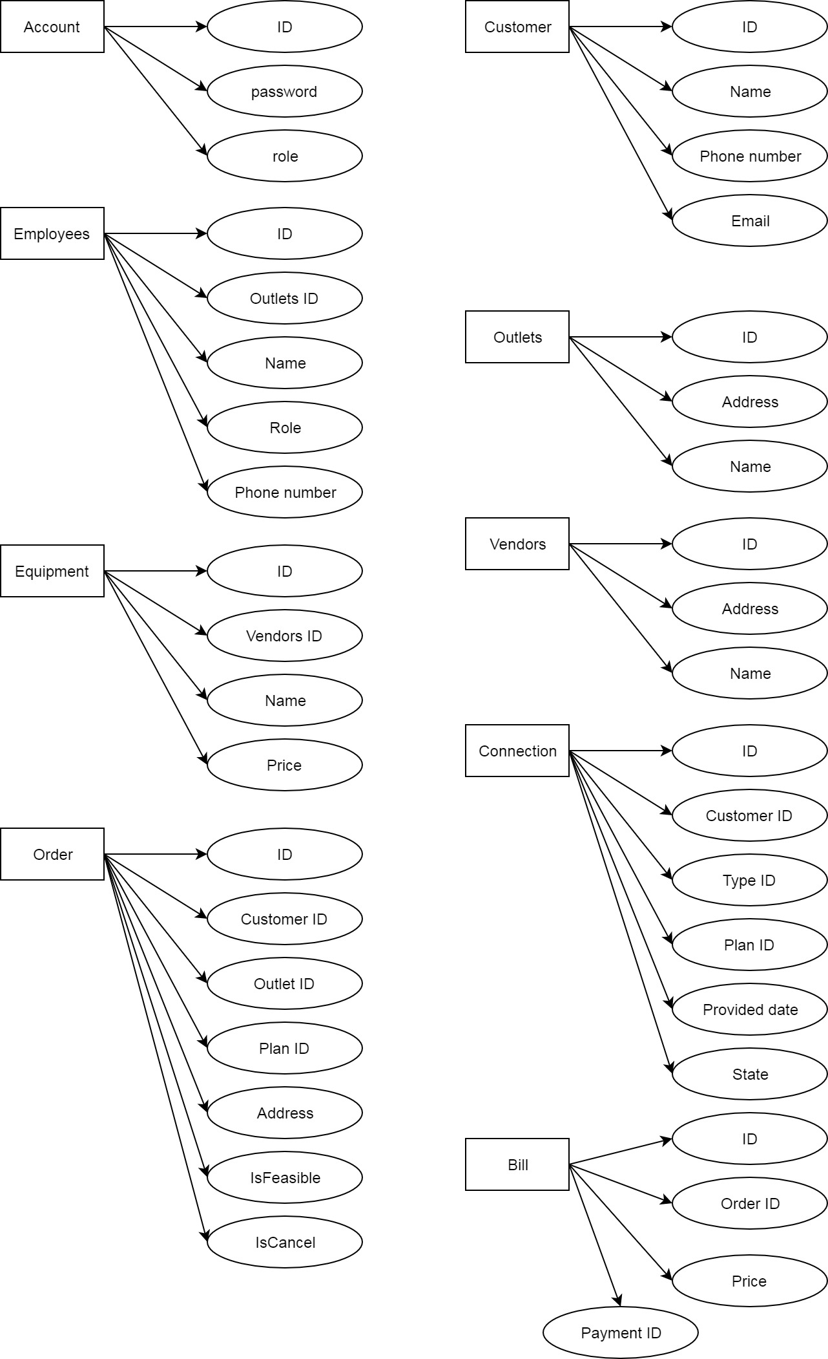

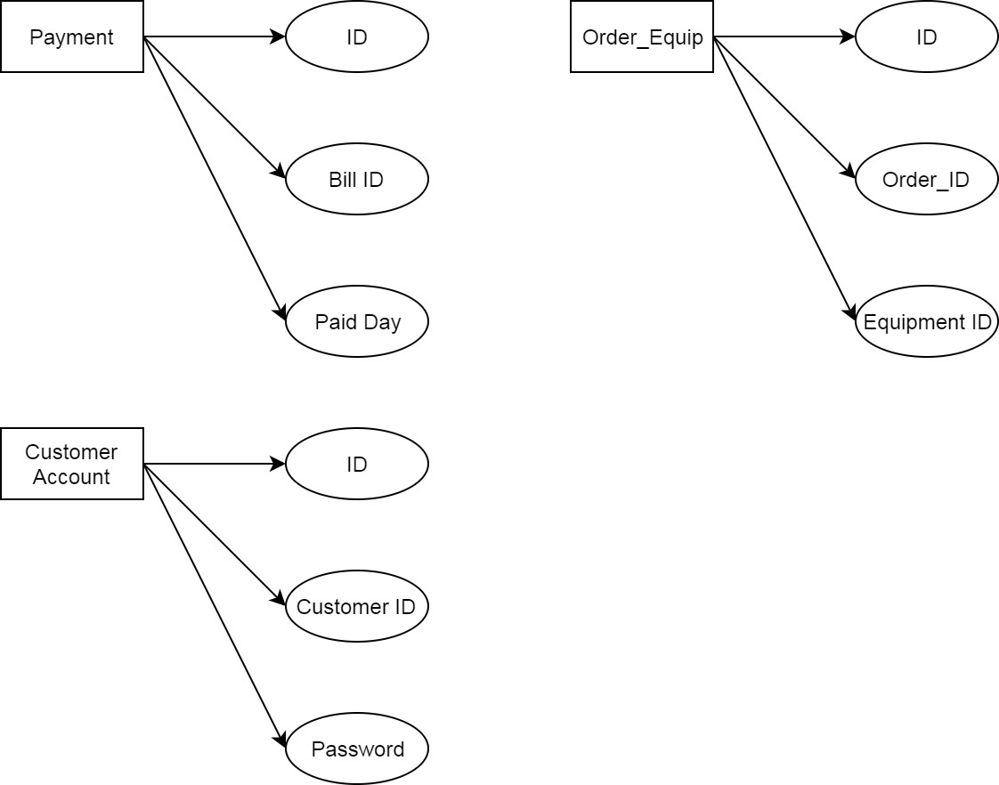

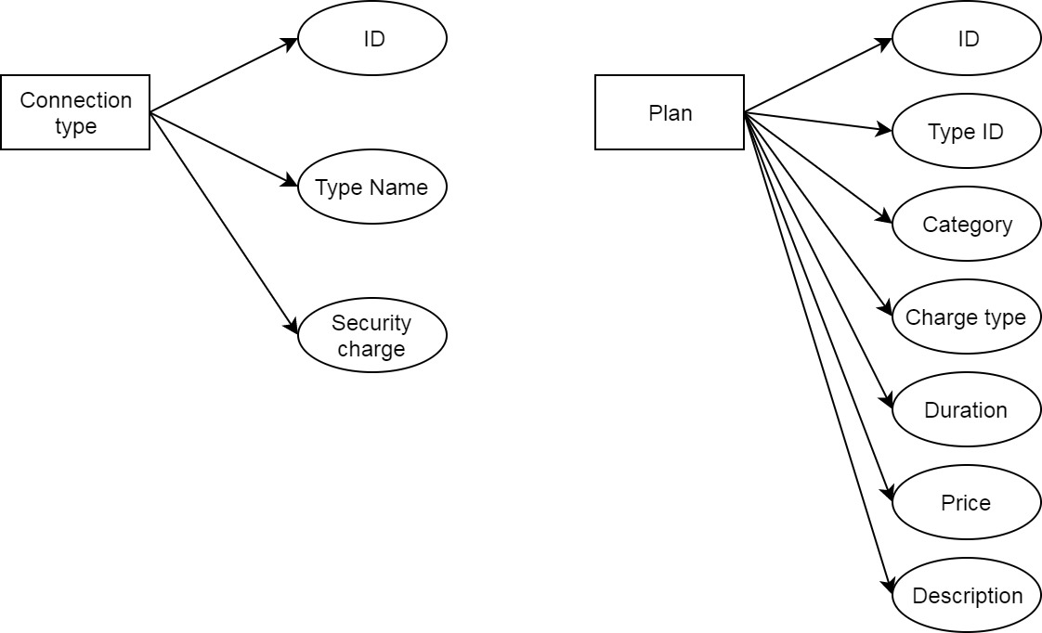

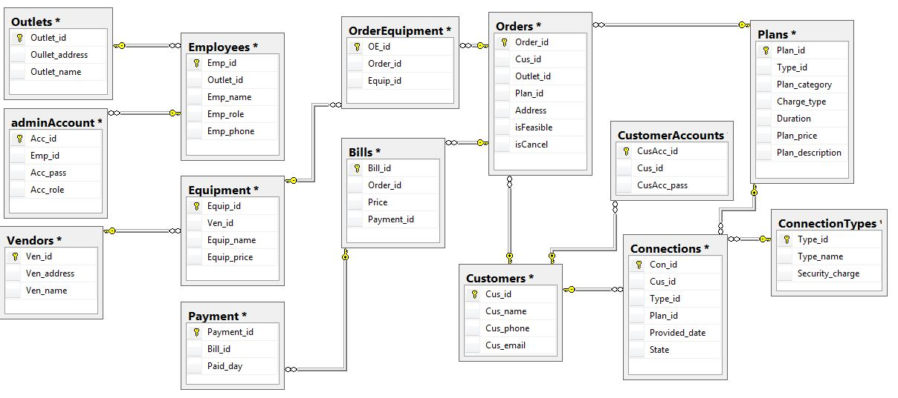

1. **Class diagram:**

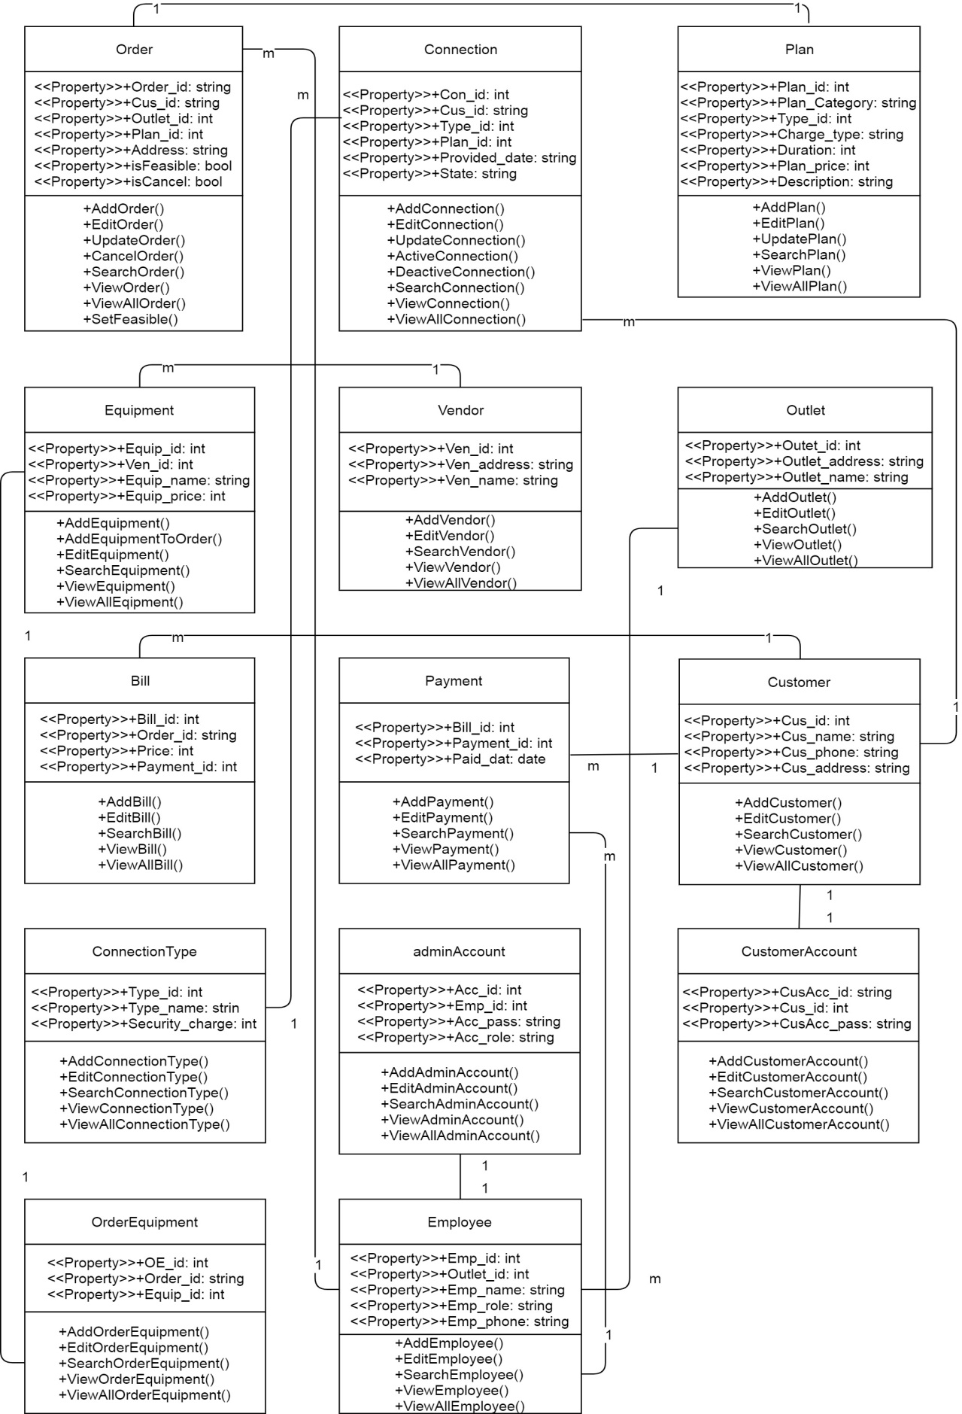

1. **Entity table:**

**Orders:**

|  |  |  |  |  |  |  |
| --- | --- | --- | --- | --- | --- | --- |
| Field Name | DataType | Size | Null | Key | Table-Field-Ref | Description |
| Order_id | Varchar | 16 | No | PK |  | Order id |
| Cus_id | int |  | No | FK | Customers - Cus_id | Customer id |
| Outlet_id | int |  | No | FK | Oulets - Outlet_id | Outlet id |
| Plan_id | int |  | No |  |  | Plan id |
| Address | varchar | 30 | No |  |  | Place to provide |
| IsFeasible | bit | True/False | Yes |  |  | Feasibility check |
| IsCancel | bit | True/False | Yes |  |  | Cancelation check |

**Connections:**

|  |  |  |  |  |  |  |
| --- | --- | --- | --- | --- | --- | --- |
| Field Name | DataType | Size | Null | Key | Table-Field-Ref | Description |
| Con_id | int |  | No | PK |  | Order id |
| Cus_id | int |  | No | FK | Customers - Cus_id | Customer id |
| Type_id | int |  | No | FK | ConnectionType - Type_id | Type id |
| Plan_id | int |  | No | FK | Plans - Plan_id | Plan id |
| Provided_date | date |  | Yes |  |  | Provided date |
| State | varchar | 20 | Yes |  |  | State of connection |

**Plans:**

|  |  |  |  |  |  |  |
| --- | --- | --- | --- | --- | --- | --- |
| Field Name | DataType | Size | Null | Key | Table-Field-Ref | Description |
| Plan_id | int |  | No | PK |  | Plan id |
| Type_id | int |  | No | FK | ConnectionType - Type_id | Type id |
| Plan_category | varchar | 30 | No |  |  | Plan category |
| Charge_type | varchar | 30 | No |  |  | Type of charge |
| Duration | int |  | No |  |  | time |
| Plan_price | int |  | No |  |  | Service price |
| Plan_description | varchar | 50 | Yes |  |  | detail |

**Equipment:**

|  |  |  |  |  |  |  |
| --- | --- | --- | --- | --- | --- | --- |
| Field Name | DataType | Size | Null | Key | Table-Field-Ref | Description |
| Equip_id | int |  | No | PK |  | Equipment id |
| Ven_id | int |  | No | FK | Vendors - Ven_id | vendor id |
| Equip_name | varchar | 30 | No |  |  | Equipment name |
| Equip_price | int |  | No |  |  | Price of equipment |

**Vendors:**

|  |  |  |  |  |  |  |
| --- | --- | --- | --- | --- | --- | --- |
| Field Name | DataType | Size | Null | Key | Table-Field-Ref | Description |
| Ven_id | int |  | No | PK |  | vendor id |
| Ven_address | varchar | 30 | No |  |  | Vendor address |
| Ven_name | varchar | 30 | No |  |  | Vendor name |

**Outlet:**

|  |  |  |  |  |  |  |
| --- | --- | --- | --- | --- | --- | --- |
| Field Name | DataType | Size | Null | Key | Table-Field-Ref | Description |
| Outlet_id | it |  | No | PK |  | Outlet id |
| Outlet_address | varchar | 30 | No |  |  | Outlet address |
| Outlet_name | varchar | 30 | No |  |  | Outlet name |

**Bill:**

|  |  |  |  |  |  |  |
| --- | --- | --- | --- | --- | --- | --- |
| Field Name | DataType | Size | Null | Key | Table-Field-Ref | Description |
| Bill_id | int |  | No | PK |  | Bill id |
| Order_id | varchar | 16 | No | FK | Orders - Order_id | Order id |
| Price | int |  | No |  |  | Total price  Including security charge |
| Payment_id | int |  | Yes |  |  | Payment id |

**Payment:**

|  |  |  |  |  |  |  |
| --- | --- | --- | --- | --- | --- | --- |
| Field Name | DataType | Size | Null | Key | Table-Field-Ref | Description |
| Payment_id | int |  | No | PK |  | Payment id |
| Bill_id | int |  | No | FK | Bills - Bill_id | Bill id |
| Paid_date | date |  | No |  |  | Paid date |

**Customer:**

|  |  |  |  |  |  |  |
| --- | --- | --- | --- | --- | --- | --- |
| Field Name | DataType | Size | Null | Key | Table-Field-Ref | Description |
| Cus_id | int |  | No | PK |  | Customer id |
| Cus_name | varchar | 30 | No |  |  | Customer name |
| Cus_phone | varchar | 10 | No |  |  | Customer phone |
| Cus_email | varchar | 30 | yes |  |  | Customer email |

**CustomerAccount:**

|  |  |  |  |  |  |  |
| --- | --- | --- | --- | --- | --- | --- |
| Field Name | DataType | Size | Null | Key | Table-Field-Ref | Description |
| CusAcc_id | varchar | 16 | No | PK |  | Customer account id |
| Cus_id | int |  | No | FK | Customers - Cus_id | Customer account id |
| CusAcc_pass | varchar | 10 | No |  |  | Customer account pass |

**AdminAccount:**

|  |  |  |  |  |  |  |
| --- | --- | --- | --- | --- | --- | --- |
| Field Name | DataType | Size | Null | Key | Table-Field-Ref | Description |
| Acc_id | int | 16 | No | PK |  | Admin id |
| Emp_id | int |  | No | FK | Employees - Emp_id | Employee id |
| Acc_pass | varchar | 10 | No |  |  | Admin pass |
| Acc_role | varchar | 20 | No |  |  | Role of admin |

**ConnectionType:**

|  |  |  |  |  |  |  |
| --- | --- | --- | --- | --- | --- | --- |
| Field Name | DataType | Size | Null | Key | Table-Field-Ref | Description |
| Type_id | int |  | No | PK |  | Type id |
| Type_name | varchar | 20 | No |  |  | Type name |
| Security_charge | int |  | No |  |  | Security charge |

**Employee:**

|  |  |  |  |  |  |  |
| --- | --- | --- | --- | --- | --- | --- |
| Field Name | DataType | Size | Null | Key | Table-Field-Ref | Description |
| Emp_id | int |  | No | PK |  | Employee id |
| Outlet_id | int |  | No | FK | Outlets - Outlet_id | Outlet id |
| Emp_name | varchar | 30 | No |  |  | Employee name |
| Emp_role | varchar | 20 | No |  |  | Employee role |
| Emp_phone | varchar | 10 | yes |  |  | Employee phone |

**OrderEquipment:**

|  |  |  |  |  |  |  |
| --- | --- | --- | --- | --- | --- | --- |
| Field Name | DataType | Size | Null | Key | Table-Field-Ref | Description |
| OE_id | int |  | No | PK |  | id |
| Order_id | varchar | 16 | No | FK | Orders - Order_id | Order id |
| Equip_id | int |  | No | FK | Equipment - Equip_id | Equipment id |

|  |  |  |  |  |  |
| --- | --- | --- | --- | --- | --- |
| **Project Ref. No 5** | Project Title: **Nexus service marketing system** | **Date of Preparation of activity plan** | | | |
| **No.** | **Task** | **Actual Start Date** | **Actual Days** | **Team Member names** | **Status** |
| 1 | Architecture of project  Algorithms – Data flowchart: |  | 2 | NGUYEN THANH PHAT | Completed |
| 2 | Algorithms – Data flowchart: | PHAM HUYNH XUAN LOC | Completed |
| 3 | Data flow diagram  Sequence diagram  Entity – relationship design | NGUYEN HUU MINH | Completed |
| 4 | Task sheet | All members | Completed |

|  |  |  |
| --- | --- | --- |
|  | **Prepare By: Group 5** | **Approved By: Faculty** |
| Date: | **Team Leader**  **Nguyen Huu Minh** | **Mr. Dinh Vu Quoc Trung** |

**REVIEW 3**

**A - Client**

**1) Index:**

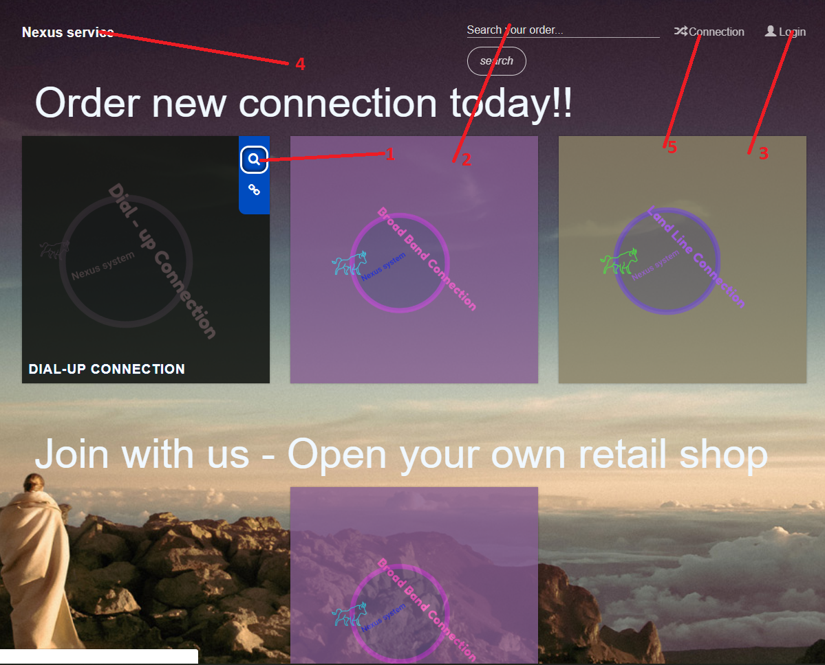

|  |  |  |  |  |  |  |
| --- | --- | --- | --- | --- | --- | --- |
| Index | | | | | | |
| No. | Name | Validation | Event | Description | Status | Type |
| 1 | Button Connection |  | Click | Open Pop up Connection table | Enable | Button |
| 2 | Search | Only number and character |  | Input information | Enable | Textbox |
| 3 | Button login |  | Click | Redirect to login page | Enable | Button |
| 4 | Home button |  | Click | Redirect to Index page | Enable | Button |
| 5 | Connection button | Only login | Click | Redirect to Connection page | Enable | button |

**2) Pop up Connection table:**

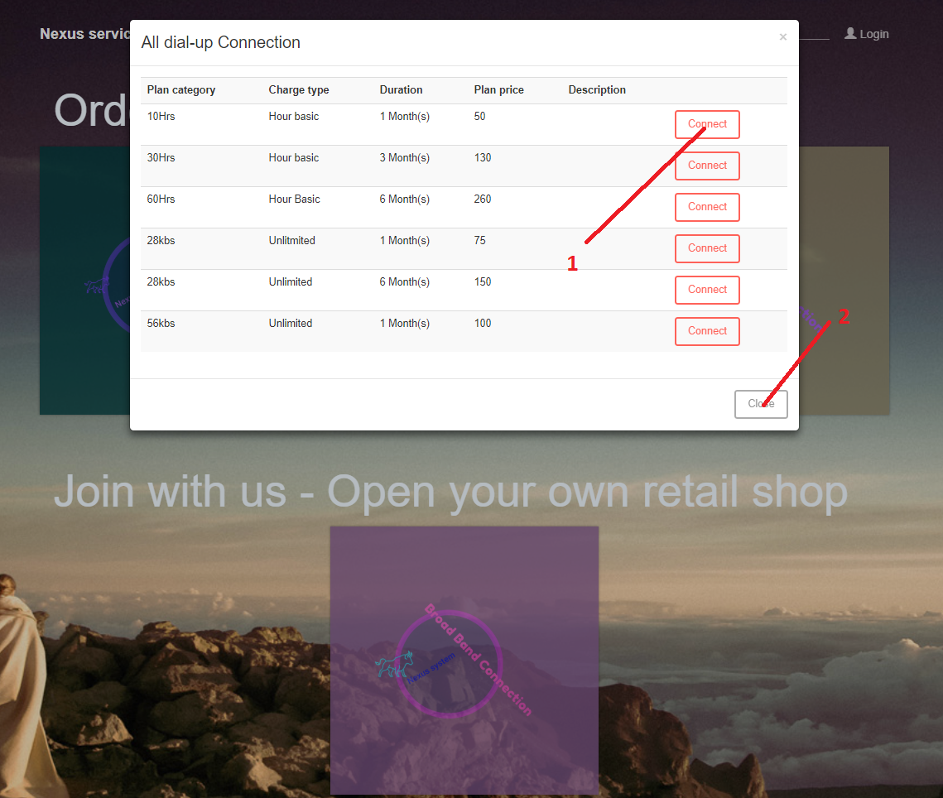

|  |  |  |  |  |  |  |
| --- | --- | --- | --- | --- | --- | --- |
| Pop up Connection table | | | | | | |
| No. | Name | Validation | Event | Description | Status | Type |
| 1 | Button Connect |  | Click | Open Pop up Order connect | Enable | Button |
| 2 | Button cancel |  | Click | Cancel the pop up | Enable | Button |

**3) Pop up Order connect:**

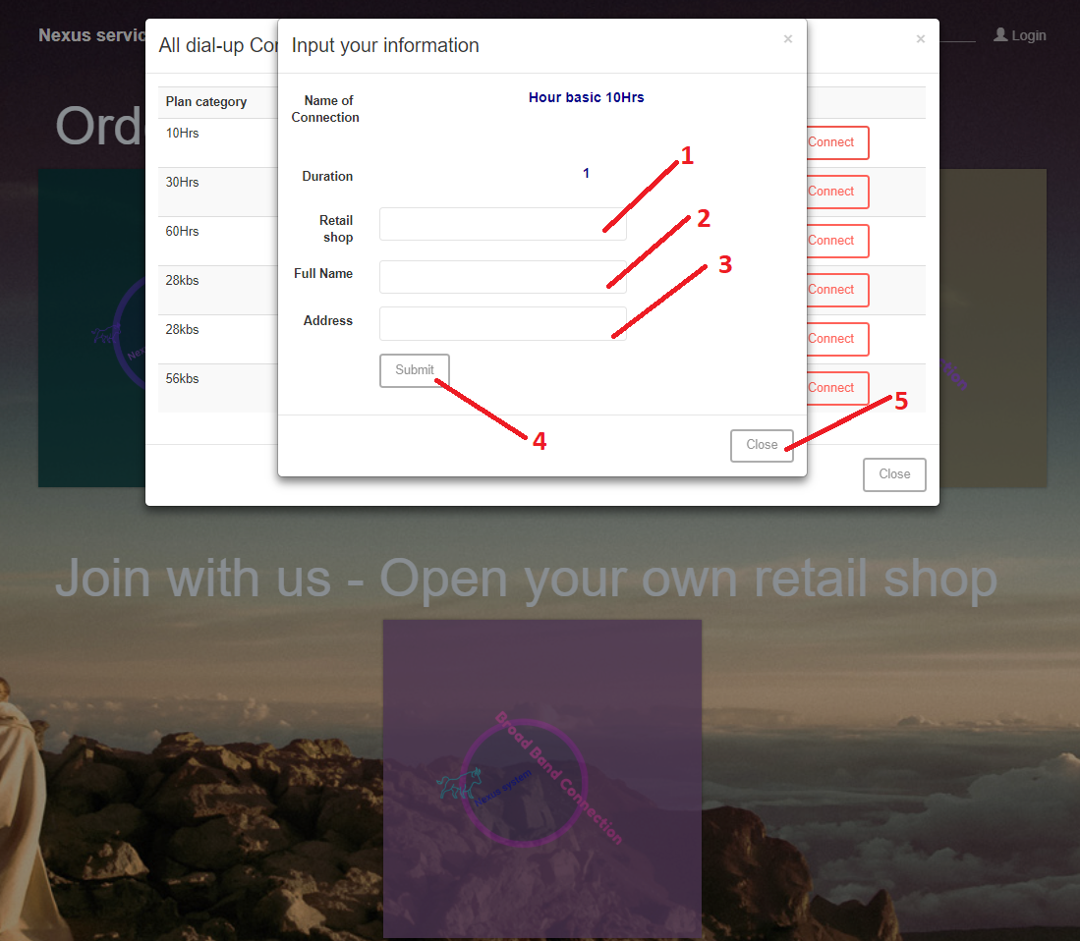

|  |  |  |  |  |  |  |
| --- | --- | --- | --- | --- | --- | --- |
| Pop up Orders | | | | | | |
| No. | Name | Validation | Event | Description | Status | Type |
| 1 | Txt Retail | Choose retail in data | Dropbox | Choose retail from drop down list | Enable | Drop-down list |
| 2 | txtName | Not null  Nvarchar(50)  Only character |  | Input customer name | Enable | Text |
| 3 | txtAddress | Not null |  | Input address | Enable | Text |
| 4 | Btnsubmit |  | Click | Submit form order | Enable | Button |
| 5 | Btn Cancel |  | Click | Cancel form Orders | Enable | Button |

**4) View Customer information:**

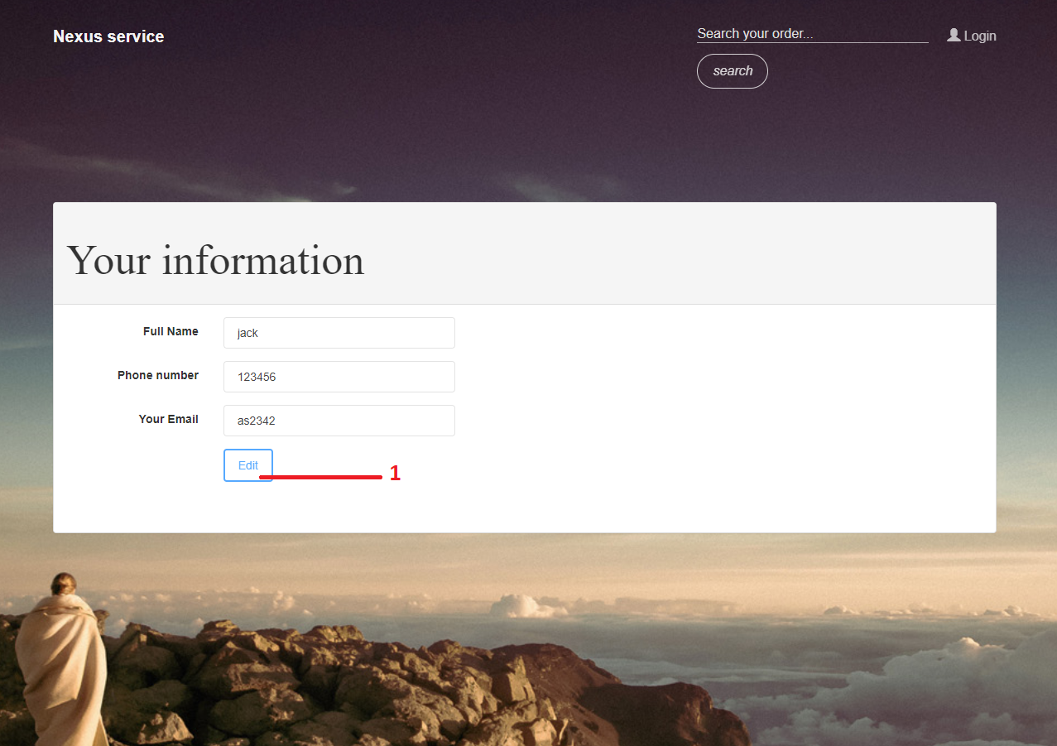

|  |  |  |  |  |  |  |
| --- | --- | --- | --- | --- | --- | --- |
| Pop up Orders | | | | | | |
| No. | Name | Validation | Event | Description | Status | Type |
| 1 | Btn Edit |  | Click | Edit information of Customer | Enable | button |

**5)** **Edit Customer information:**

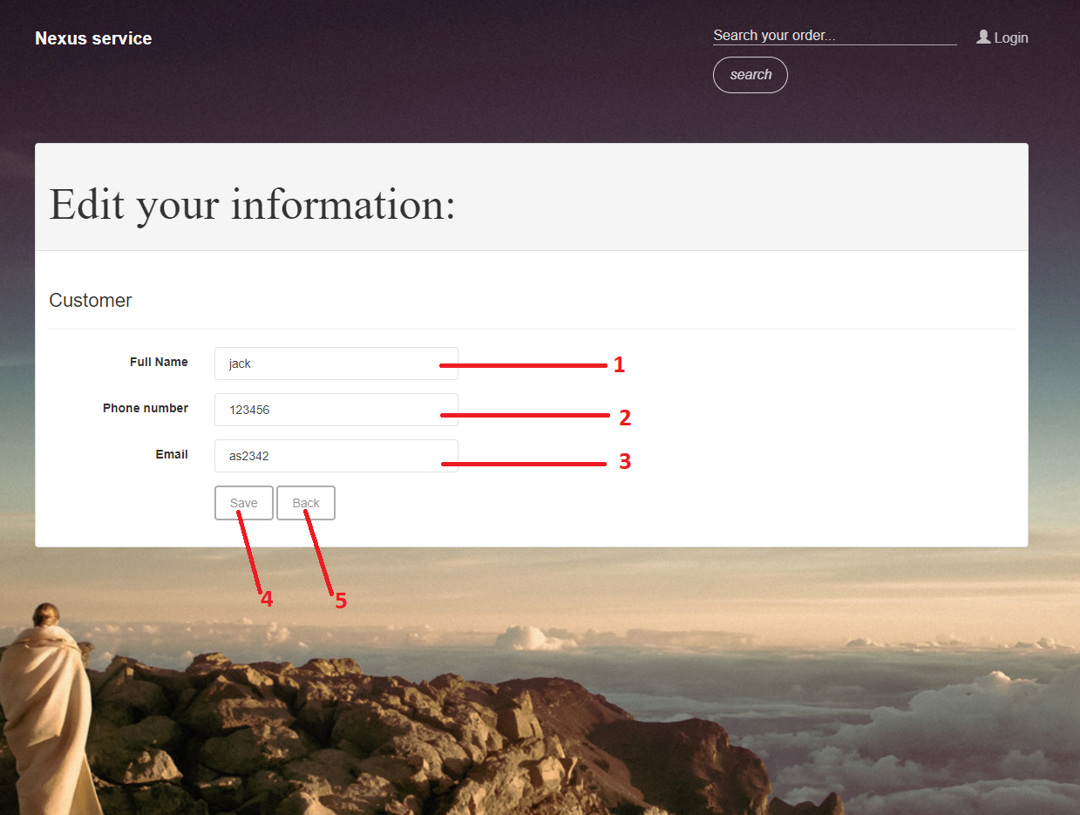

|  |  |  |  |  |  |  |
| --- | --- | --- | --- | --- | --- | --- |
| Pop up Orders | | | | | | |
| No. | Name | Validation | Event | Description | Status | Type |
| 1 | Txtname | Not null  Nvarchar(50)  Only character |  | Input customer name | Enable | Text |
| 2 | Phonenumber | Only number |  | Input customer phone number | Enable | Text |
| 3 | Email | Not null  Only Email |  | Input Email | Enable | Text |
| 4 | BtnSave |  | Click | Submit form edit | Enable | Button |
| 5 | Btn Cancel |  | Click | Cancel form edit | Enable | Button |

**6) View Orders:**

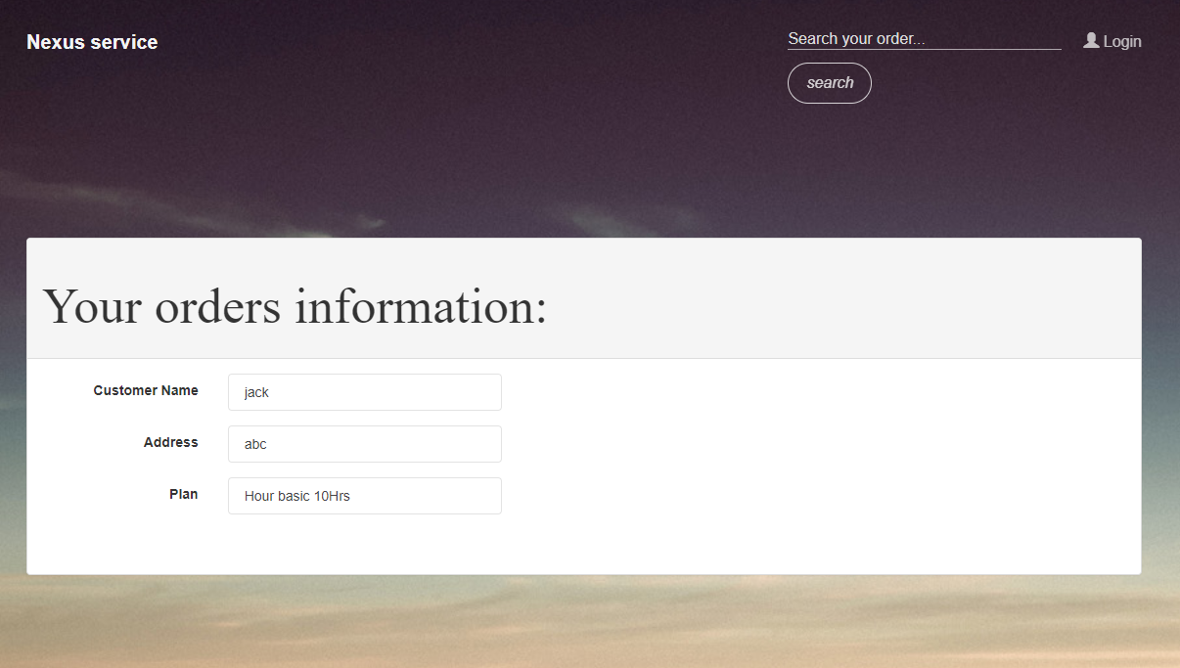

**7) View Connection**

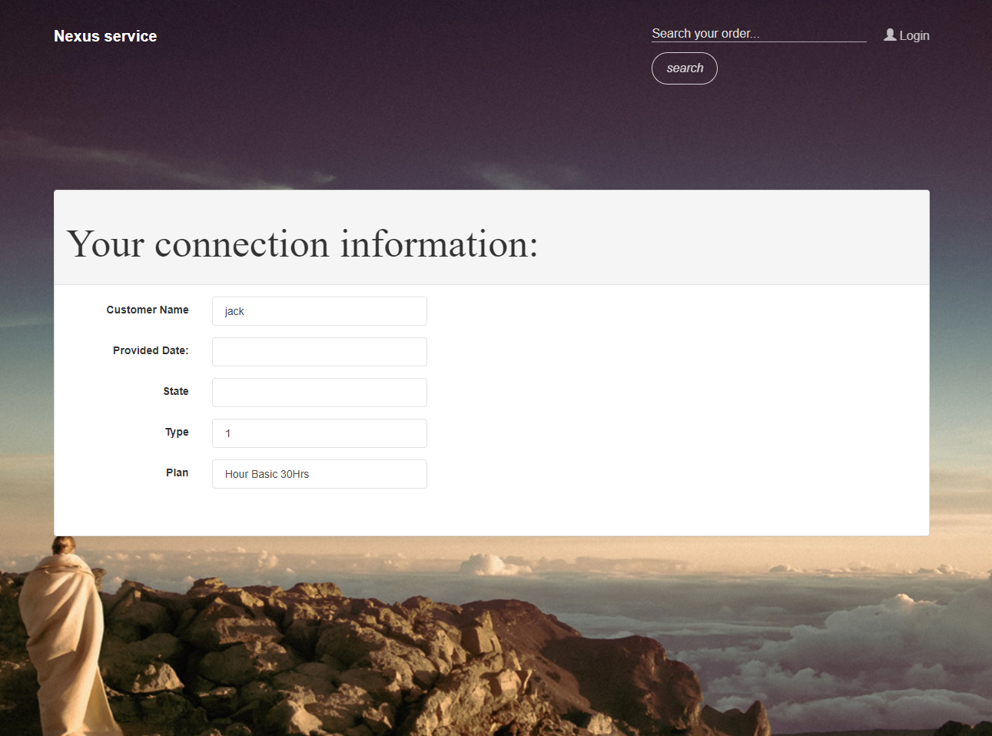

**B - Administrator:**

**1) Admin Homepage:**

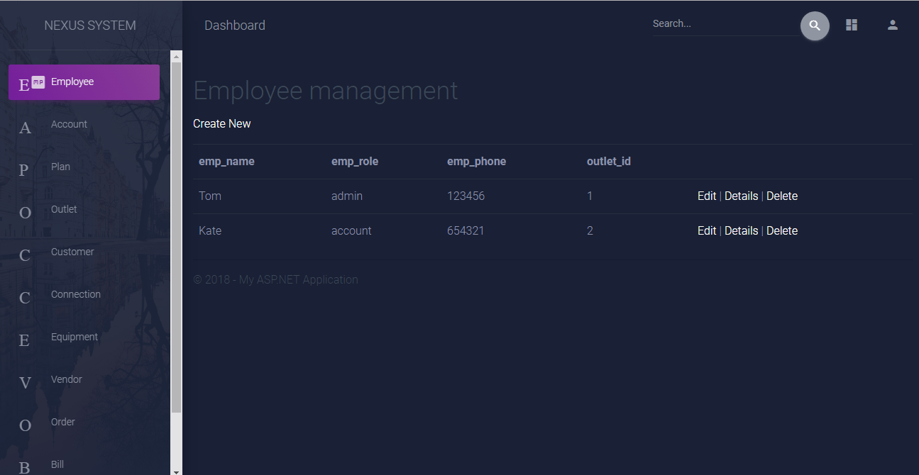

**18**

**17**

**16**

**15**

**14**

**13**

**12**

**11**

**10**

**8**

**9**

**1**

**7**

**4**

**6**

**5**

**3**

**2**



|  |  |  |  |  |  |  |
| --- | --- | --- | --- | --- | --- | --- |
| **No** | **Name** | **Type** | **Validation** | **Event** | **Descripstion** | **Status** |
| **1** | Employee | Text | Check for appropriate admin role | Click | Show Employee list | Enable |
| **2** | Account | Text | Check for appropriate admin role | Click | Show Account list | Enable |
| **3** | Plan | Text | Check for appropriate admin role | Click | Show Plan list | Enable |
| **4** | Outlet | Text | Check for appropriate admin role | Click | Show Outlet list | Enable |
| **5** | Customer | Text | Check for appropriate admin role | Click | Show Customer list | Enable |
| **6** | Connection | Text | Check for appropriate admin role | Click | Show Connection list | Enable |
| **7** | Equipment | Text | Check for appropriate admin role | Click | Show Equipment list | Enable |
| **6** | Vendor | Text | Check for appropriate admin role | Click | Show Vendor list | Enable |
| **9** | Order | Text | Check for appropriate admin role | Click | Show Order list | Enable |
| **10** | Bill | Text | Check for appropriate admin role | Click | Show Bill list | Enable |
| **11** | Payment | Text | Check for appropriate admin role | Click | Show Payment list | Enable |
| **12** | Create New | Text | Check for appropriate admin role | Click | Link to create page | Enable |
| **13** | Edit | Text | Check for appropriate admin role | Click | Link to edit page | Enable |
| **14** | Details | Text | Check for appropriate admin role | Click | Link to details page | Enable |
| **15** | Delete | Text | Check for appropriate admin role | Click | Link to delete page | Enable |
| **16** | Search bar | TextBox | Not contain special characters | Input | Search content | Enable |
| **17** | Search Icon | Button | Search bar is not null | Click | Show search result | Enable |
| **18** | Login Icon | Button |  | Click | Logout option | Enable |

**2) Create page:**

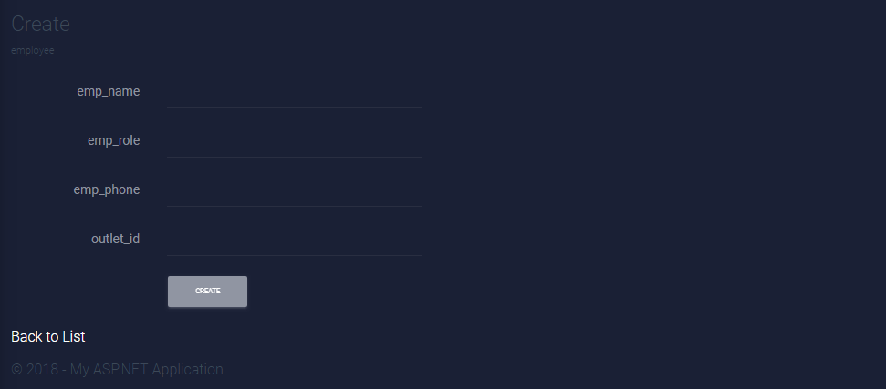

**1**

**3**

**2**

|  |  |  |  |  |  |  |
| --- | --- | --- | --- | --- | --- | --- |
| **No** | **Name** | **Type** | **Validation** | **Event** | **Descripstion** | **Status** |
| **1** | Input field | Text | Check for appropriate data input | Input | New input data | Enable |
| **2** | Create button | Button |  | Click | Create new object | Enable |
| **3** | Back to List | Text |  | Click | Back to previous list | Enable |

**3) Detail page**:

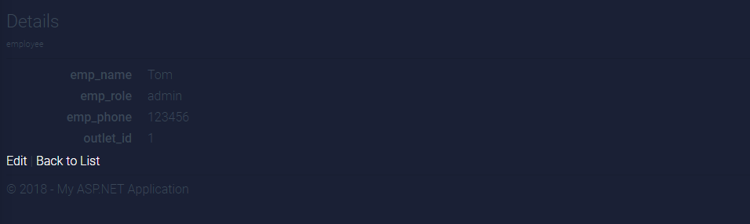

**2**

**1**

|  |  |  |  |  |  |  |
| --- | --- | --- | --- | --- | --- | --- |
| **No** | **Name** | **Type** | **Validation** | **Event** | **Descripstion** | **Status** |
| **1** | Data field | Text |  |  | Show details information | Enable |
| **2** | Back to list | Text |  | Click | Back to previous list | Enable |

**4) Edit page:**

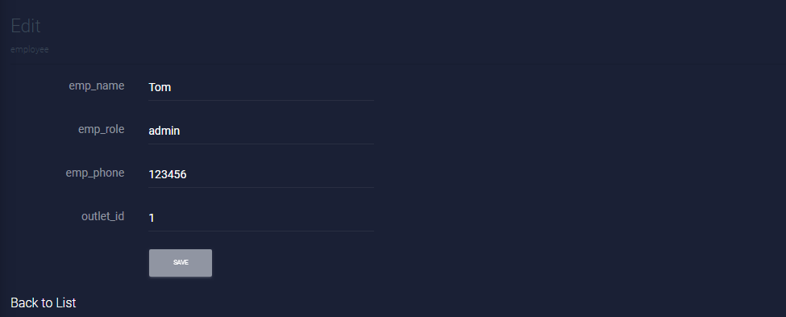

**3**

**2**

**1**

|  |  |  |  |  |  |  |
| --- | --- | --- | --- | --- | --- | --- |
| **No** | **Name** | **Type** | **Validation** | **Event** | **Descripstion** | **Status** |
| **1** | Input field | Text | Check for appropriate data input | Input | New input data | Enable |
| **2** | Save button | Button |  | Click | Update data | Enable |
| **3** | Back to List | Text |  | Click | Back to previous list | Enable |

**5) Delete page:**

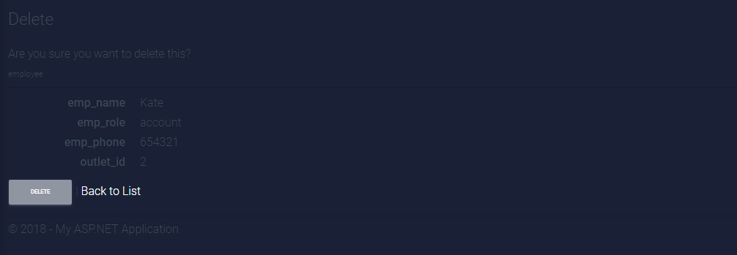

**3**

**2**

**1**

|  |  |  |  |  |  |  |
| --- | --- | --- | --- | --- | --- | --- |
| **No** | **Name** | **Type** | **Validation** | **Event** | **Descripstion** | **Status** |
| **1** | Data field | Text |  |  | Show details information | Enable |
| **2** | Delete button | Button |  | Click | Delete selected object | Enable |
| **3** | Back to List | Text |  | Click | Back to previous list | Enable |

s

|  |  |  |  |  |  |
| --- | --- | --- | --- | --- | --- |
| **Project Ref. No 5** | Project Title: **Nexus service marketing system** | **Date of Preparation of activity plan** | | | |
| **No.** | **Task** | **Actual Start Date** | **Actual Days** | **Team Member names** | **Status** |
| 1 | **Client site:**  - Index  - Pop up Connection table  - Pop up Order connect  - View Customer information  - Edit Customer information |  | 5 | NGUYEN THANH PHAT | Completed |
| 2 | **Client site:**  - View Orders  - View Connection  - Search bar  **Administrator site:**  - Edit page  - Search bar  - Login Icon | PHAM HUYNH XUAN LOC | Completed |
| 3 | **Administrator site:**  - Admin homepage  - Create page  - Detail page  - Delete page | NGUYEN HUU MINH | Completed |
| 4 | Task sheet | All members | Completed |

|  |  |  |
| --- | --- | --- |
|  | **Prepare By: Group 5** | **Approved By: Faculty** |
| Date: | **Team Leader**  **Nguyen Huu Minh** | **Mr. Dinh Vu Quoc Trung** |